

# MINI PROJECT REPORT

*On*

**ECON CARD**

*Submitted in partial fulfilment for the award of degree*

*Of*

***Master of Computer Applications***

*By*

**KARTHIK PRASAD**

**(MLM24MCA-2032)**

Under the Guidance of

## Ms. Ashwani Vijayachandran

(Assistant Professor, Department of Computer Applications)



**DEPARTMENT OF COMPUTER APPLICATIONS**  **MANGALAM COLLEGE OF ENGINEERING, ETTUMANOOR**

***(Affiliated to APJ Abdul Kalam Technological University)***

# OCTOBER 2025

**MAPPING OF PO-PSO-SDG**

**1. MAPPING WITH PROGRAM OUTCOMES (POs):-**

|  |  |  |
| --- | --- | --- |
| **SL. NO** | **POs ADDRESSED** | **RELEVANCE TO PROJECT** |
| 1 | PO3- Design/Development of Solutions | It focuses on designing and developing an efficient digital solution to automate and streamline the student concession card management process. |
| 2 | PO5- Modern Tool Usage | It involves using modern web technologies and development tools to design, implement, and manage an efficient online concession card generation system. |

**LIST OF PROGRAM OUTCOMES (POs):**

**PO1 – Engineering Knowledge:** Apply knowledge of mathematics, science, engineering fundamentals, and an engineering specialization to solve complex engineering problems.

**PO2 – Problem Analysis**: Identify, formulate, research literature, and analyse complex engineering problems reaching substantiated conclusions using first principles of mathematics, natural sciences, and engineering sciences.

**PO3 – Design/Development of Solutions**: Design solutions for complex engineering problems and design systems, components, or processes that meet specified needs with appropriate consideration for public health and safety, cultural, societal, and environmental considerations.

**PO4 – Conduct Investigations of Complex Problems**: Use research-based knowledge and research methods including design of experiments, analysis, and interpretation of data, and synthesis of information to provide valid conclusions.

**PO5– Modern Tool Usage**: Create, select, and apply appropriate techniques, resources, and modern engineering and IT tools, including prediction and modeling, to complex engineering activities with an understanding of the limitations.

**PO6 – The Engineer and Society**: Apply reasoning informed by contextual knowledge to assess societal, health, safety, legal, and cultural issues and the consequent responsibilities relevant to professional engineering practice.

**PO7 – Environment and Sustainability**: Understand the impact of professional engineering solutions in societal and environmental contexts and demonstrate knowledge of, and need for sustainable development.

**PO8 – Ethics**: Apply ethical principles and commit to professional ethics and responsibilities and norms of engineering practice.

**PO9 – Individual and Team Work**: Function effectively as an individual, and as a member or leader in diverse teams, and in multidisciplinary settings.

**PO10 – Communication**: Communicate effectively on complex engineering activities with the engineering community and with society at large, such as being able to comprehend and write effective reports and design documentation, make effective presentations, and give and receive clear instructions. **PO11– Project Management and Finance**: Demonstrate knowledge and understanding of engineering and management principles and apply these to one’s own work, as a member and leader in a team, to manage projects and in multidisciplinary environments.

**PO12 – Lifelong Learning**: Recognize the need for, and have the ability to engage in independent and life-long learning in the broadest context of technological change.

1. **MAPPING WITH PROGRAM SPECIFIC OUTCOMES (PSOs):**

|  |  |  |
| --- | --- | --- |
| **SL.NO** | **PSOs ADDRESSED** | **RELEVANCE TO PROJECT** |
| 1 | PSO 2 | It applies computing principles to design and implement a sustainable digital solution that replaces manual concession card processing with an efficient, paperless online system. |

**LIST OF PROGRAM SPECIFIC OUTCOMES (PSOs):**

**PSO 1**: Apply advanced technologies through innovations to enhance the efficiency of design development.

**PSO 2**: Apply the principles of computing to analyze, design and implement sustainable solutions for real world challenges.

1. **MAPPING WITH SUSTAINABLE DEVELOPMENT GOALS (SDGs):**

|  |  |  |
| --- | --- | --- |
| **SDG NO** | **SDGs ADDRESSED** | **RELEVANCE TO PROJECT** |
| SDG 9 | Industry, Innovation, and Infrastructure | It promotes digital innovation and sustainable infrastructure by developing an online platform that modernizes the traditional concession card system through automation and smart technology. |
| SDG 12 | Responsible  Consumption and  Production | It encourages paperless processing through digital concession cards, reducing resource consumption and promoting ecofriendly, sustainable management practices. |

**SUSTAINABLE DEVELOPMENT GOALS (SDGs):**

**SDG 1 – No Poverty**-End poverty in all its forms everywhere.

**SDG 2 – Zero Hunger**-End hunger, achieve food security and improved nutrition, and promote sustainable agriculture.

**SDG 3 – Good Health and Well-Being**-Ensure healthy lives and promote well-being for all at all ages. **SDG 4 – Quality Education**-Ensure inclusive and equitable quality education and promote lifelong learning opportunities for all.

**SDG 5 – Gender Equality**-Achieve gender equality and empower all women and girls.

**SDG 6 – Clean Water and Sanitation**-Ensure availability and sustainable management of water and sanitation for all.

**SDG 7 – Affordable and Clean Energy**-Ensure access to affordable, reliable, sustainable, and modern energy for all.

**SDG 8 – Decent Work and Economic Growth**-Promote sustained, inclusive, and sustainable economic growth, full and productive employment, and decent work for all.

**SDG 9 – Industry, Innovation, and Infrastructure**-Build resilient infrastructure, promote inclusive and sustainable industrialization, and foster innovation.

**SDG 10 – Reduced Inequality**-Reduce inequality within and among countries.

**SDG 11 – Sustainable Cities and Communities**-Make cities and human settlements inclusive, safe, resilient, and sustainable.

**SDG 12 – Responsible Consumption and Production**-Ensure sustainable consumption and production patterns.

**SDG 13 – Climate Action**-Take urgent action to combat climate change and its impacts.

**SDG 14 – Life Below Water**-Conserve and sustainably use the oceans, seas, and marine resources. **SDG 15 – Life on Land** -Protect, restore, and promote sustainable use of terrestrial ecosystems, manage forests sustainably, combat desertification, halt and reverse land degradation, and halt biodiversity loss. **SDG 16 – Peace, Justice, and Strong Institutions**- Promote peaceful and inclusive societies, provide access to justice for all, and build effective, accountable, and inclusive institutions.

**SDG 17 – Partnerships for the Goals** -Strengthen the means of implementation and revitalize the global partnership for sustainable development.

## MANGALAM COLLEGE OF ENGINEERING, ETTUMANOOR DEPARTMENT OF COMPUTER APPLICATIONS OCTOBER 2025



### *DECLARATION*

*I hereby certify that the work which is being presented in the project entitled “ECON CARD” submitted in the* ***DEPARTMENT OF COMPUTER APPLICATIONS*** *is an authentic record of my own work*

*carried under the supervision of* ***Ms. ASHWANI VIJAYACHANDRAN, ASSISTANT PROFESSOR.*** *This study has not been submitted to any other institution or university for the award of any other degree. This report has been checked for plagiarism by the college and the similarity index is within permissible limits set by the college.*

**KARTHIK PRASAD**

*Date:*

*Place:*

## MANGALAM COLLEGE OF ENGINEERING, ETTUMANOOR DEPARTMENT OF COMPUTER APPLICATIONS

## OCTOBER 2025



### *CERTIFICATE*

*This is to certify that the Project titled “****ECON CARD****” is the bonafide record of the work done* ***by KARTHIK PRASAD (MLM24MCA-2032****) of Master of Computer Applications towards the partial fulfilment of the requirement for the award of the MASTER OF COMPUTER APPLICATIONS by* ***APJ ABDUL KALAM TECHNOLOGICAL UNIVERSITY****, during the academic year 2025-2026.*

**Internal Examiner**  **Project Guide**

**Ms. Banu Sumayya S**

**Assistant Professor**

**Department of Computer Applications**

**Project Guide**  **Head of the Department**

**Ms. Ashwani Vijayachandran** **Ms. Divya S B**

**Assistant Professor**  **Associate Professor**

**Department of Computer Applications**  **Department of Computer Applications**

# ACKNOWLEDGEMENT

I am greatly indebted to the authorities of Mangalam College of Engineering for providing the necessary facilities to successfully complete my Project on the topic “ECON CARD”.

I express my sincere thanks to **Dr. Vinodh P Vijayan**, Principal, Mangalam College of Engineering for providing the facilities to complete my Project successfully.

I thank and express my solicit gratitude to **Ms. Divya S B,** HOD, Department of Computer Applications, Mangalam College of Engineering, for her invaluable help and support which helped me a lot in successfully completing this Project work.

I express my gratitude to my Internal Guide, **Ms. Ashwani Vijayachandran** Associate professor, Department of Computer Applications for the suggestions and encouragement which helped in the successful completion of my Project.

Furthermore, I would like to acknowledge with much appreciation the crucial role of the faculties especially Project coordinator, **Ms. Banu Sumayya S**, Department of Computer Applications, Mangalam College of Engineering, who gave the permission to use all the required equipment and the necessary resources to complete the presentation & report.

Finally, I would like to express my heartfelt thanks to my parents who were very supportive both financially and mentally and for their encouragement to achieve my goal.

**KARTHIK PRASAD(MLM24MCA2032)**

# ABSTRACT

Econ card is an innovative smart water delivery system designed to automate and streamline the entire water supply management process, addressing challenges such as delayed deliveries, inefficient scheduling, and manual errors. The system enables users to register securely and place water requests according to their requirements. Users can also check water availability in real time and make payments conveniently through an integrated payment gateway, ensuring a smooth and seamless experience.

On the administrative side, the system allows admins to verify user requests, approve payments, and efficiently assign delivery tasks to available tankers. This ensures optimal allocation of resources and timely delivery. Users receive real-time notifications and updates on the status of their requests and deliveries, improving transparency and reducing uncertainty.

The project is developed using Python and Django for robust backend operations, while HTML, CSS, and JavaScript are used to create an intuitive and responsive frontend interface. The system leverages a secure database to store user information, water requests, payment details, and delivery records, allowing for accurate tracking and reporting. Econ card not only enhances operational efficiency and reduces manual intervention but also significantly improves user satisfaction.

Moreover, the system has the potential for future enhancements, including automated billing, predictive analytics for demand forecasting, and integration with IoT-based sensors for real-time water level monitoring and smart resource management. Econ card represents a modern, technologydriven approach to water distribution, providing a reliable and user-friendly solution for urban and semi-urban water supply systems**.**

***Keywords:***

|  |  |
| --- | --- |
| **Mapping with Sustainable Development** | 9 – Industry Innovation and Infrastructure 12– Responsible Consumption and Production |

Econ card

Department Of Computer Applications, MLMCE P a g e | **9**

**TABLE OF CONTENTS**

**CHAPTER TITLE PAGE**

**NO NO**

**List Of Figures I**

**List of Abbreviations II**

1. **INTRODUCTION 1** 
   1. Background **1**
   2. Introduction **3**
   3. Problem Statement **4**
   4. Motivation **5**
   5. Scope **6**
2. **LITERATURE REVIEW 8** 
   1. Providing Discounted Transit Passes to Younger **8**

University Students: Are there effects on Public

Transit, Car and Active Transportation trips to

University

* 1. NJ Transit Student Discount Program Expands to Include **9**

PartTime Students

* 1. KSRTC Card System **9**
  2. Digitalizing the Student Concession Card **10**
  3. Smart Card-Based Public Transportation System for **11**

Students

* 1. Digital Concession Card Management System for **13**

Educational Institutions

* 1. Smart Transport Pass Issuance Using QR-Code Based **14**

Digital Identity

* 1. Web-Based Student Pass Issuance and Verification **15**

System

* 1. Smart Digital Concession Card with Tap-and-Pay **16**

Technology for Students

* 1. Smart Digital Concession Card with Tap-and-Pay **16**

Technology forStudents

1. **PROPOSED SYSTEM 18** 
   1. Users **18**
   2. Registration **18**
   3. Login **18**
   4. Concession Card Request Submission **19**
   5. Notification **19**
   6. Download Digital Concession Card **19**
   7. Transport Officer **20**
   8. Verify Eligibility **20**
   9. Approve/Reject Request **20**
   10. Notification to User **21**
   11. Record Maintenance. **21**
2. **METHODOLOGY 22**
3. **SYSTEM ARCHITECTURE 25** 
   1. Over View of System Architecture  **25**
   2. Presentation Layer  **26**
   3. Application Layer  **26**
   4. Database Layer **27**
   5. System Communication Flow **28**
   6. Security and Reliability **29**
4. **MODULES 30** 6.1 User **30** 
   1. Admin Module **32**
   2. Transport Officer **33**
5. **DIAGRAMS 36** 
   1. Data Flow Diagrams **36** 
      1. Context Level or LEVEL 0 DFD **36**
      2. LEVELS 1 DFD **37**
      3. LEVEL 2 DFD **38**
      4. LEVEL 3 DFD **39**
   2. Use Case Diagram **40**
   3. Sequence Diagram **41**
   4. Class Diagram **42**
   5. Activity Diagrams **43**
6. **TESTING 46** 
   1. Testing **46**
   2. Unit Testing **47**
   3. Validation Testing **48**
   4. Regression Testing. **49**
   5. Integration Testing **50** 8.6 Acceptance Testing **50**
7. **ADVANTAGES & DISADVANTAGES 52**

9.1Advantages **52**

9.2Disadvantages **53**

1. **RESULTS 54**
2. **CONCLUSION & FUTURE SCOPE 56**

**APPENDICES 59**

**REFERENCES 62**

|  |  |  |
| --- | --- | --- |
|  | **LIST OF FIGURES** |  |
| **FIGURE NO.** | **TITLE** | **PAGE NO** |
| **5.1** | System Architecture | **25** |
| **6.1** | User Module | **31** |
| **6.2** | Admin Module | **33** |
| **6.3** | Transport Officer Module | **35** |
| **7.1** | Level 0 DFD | **37** |
| **7.2** | Level 1 DFD | **38** |
| **7.3** | Level 2 DFD | **39** |
| **7.4** | Level 3 DFD | **40** |
| **7.5** | Use Case Diagram | **41** |
| **7.6** | Sequence Diagram | **42** |
| **7.7** | Class Diagram | **43** |
| **7.8** | Activity Diagram | **45** |

**LIST OF ABBREVIATIONS**

|  |  |
| --- | --- |
|  |  |
| **ABBREVIATION** | **FULL FORM** |
| **DFD** | Data Flow Diagram |
| **UML** | Unified Modeling Language |
| **AI** | Artificial Intelligence |
| **CRUD** | Create, Read, Update, Delete |
| **DBMS** | Database Management System |
| **ER** | Entity Relationship |
| **HTML** | HyperText Markup Language |
| **HTTP** | HyperText Transfer Protocol |
| **SCCMS** | Student Concession Card Management System |
| **PDF** | Portable Document Format |
| **REST** | Representational State Transfer |
| **UAT** | User Acceptance Testing |
| **UI** | User Interface |
| **UX** | User Experience |
| **API** | Application Programming  Language |
| **CSS** | Cascading Style Sheets |
| **JSON** | JavaScript Object Notation |
| **URL** | Uniform Resource Locator |

**CHAPTER-1**

## INTRODUCTION

### 1.1 Background

In today’s fast-paced world, digital transformation has become a crucial element in improving the efficiency of services, especially in sectors that involve large-scale public interaction. One such area is the management of student concession cards for public transportation. Student concessions play a vital role in supporting the academic journey of millions of students by offering discounted travel fares, thereby reducing the financial burden on families. However, the traditional method of obtaining a concession card is highly manual and inefficient. Students are often required to visit their educational institutions, collect and fill out physical forms, attach supporting documents, get signatures from authorities, and then submit the forms to transport offices. This entire process is time-consuming, prone to delays, and often leads to long queues, repeated visits, and frustration among students. Manual handling of applications also increases the chances of errors, misplaced documents, and miscommunication between departments.

Furthermore, the lack of a centralized digital system results in poor coordination between students, institutions, and transportation authorities. Each institution or transport department may follow different procedures, causing inconsistency and lack of transparency. Students are not able to track the status of their applications and are sometimes left uncertain about whether their request has been approved or rejected. In addition, printing and distributing physical concession cards adds to operational costs and contributes to paper waste, making the system less sustainable. As the number of students increases every year, the traditional model becomes even more difficult to manage, leading to processing delays and administrative bottlenecks. To address these ongoing challenges, there is a strong need to introduce a modern, automated, and efficient system that can digitalize the entire concession card process. With the advancement of web technologies and online platforms, it is now possible to design a system where students can easily register, submit their details, upload required documents, and apply for a concession card from the comfort of their home. This eliminates the need for physical presence and reduces dependency on manual paperwork. The integration of a digital database enables accurate and organized storage of student information, ensuring quick access and retrieval of records whenever needed. Digital verification of applications also allows administrators and transport officers to review, approve, or reject requests in a much faster and more transparent manner.

Digital platforms not only improve the speed of processing concession card requests but also enhance transparency and accountability across all stakeholders. In a traditional system, students often face uncertainty because there is no proper communication channel to update them about the progress of their application. However, in an online system, students receive instant notifications about the status of their request—whether it is pending, approved, or rejected. This ensures clarity and keeps students informed without requiring them to make repeated visits or inquiries. Moreover, digital records provide a reliable audit trail, where every action such as submission, verification, and approval is tracked. This prevents misuse, fraud, or unauthorized access to concession benefits. Additionally, role-based access control ensures that users such as students, administrators, and transport officers only access information relevant to their role, thereby increasing data security and reducing the risk of data breaches.The adoption of an online concession card system also contributes to environmental sustainability. By eliminating the need for paper forms, physical documents, and printed cards, the system significantly reduces paper consumption. This aligns with global efforts to promote ecofriendly and green technologies in government and educational services. Furthermore, digital systems are scalable and future-proof, meaning they can easily accommodate growing numbers of users without requiring major changes to infrastructure. As transportation networks expand and the demand for student concessions increases, a well-designed online platform can handle large volumes of data and user interactions efficiently. Another important reason for developing this digital system is the growing expectation among students for faster, technology-driven solutions. Today’s students are highly familiar with online portals, mobile applications, and digital services in areas such as banking, education, ticket booking, and communication. Therefore, they expect similar convenience in applying for transport concessions.

An online concession card system meets these expectations by offering a user-friendly interface, seamless navigation, and quick processing. It reflects modernization and aligns educational institutions and transport authorities with the digital transformation happening across various sectors. It also strengthens the relationship between students and institutions by showing that the system cares about accessibility and convenience. In addition to student benefits, the digital system reduces the workload of administrators and transport officers. Traditionally, staff members spend hours manually checking documents, validating student data, signing forms, and managing physical records. This repetitive work leads to human fatigue and increases the chances of mistakes or delays. With the introduction of automation, routine tasks such as data validation, record management, and approval tracking can be handled by the system itself. Administrators only need to focus on decision-making rather than paperwork. This saves time, improves efficiency, and allows staff to dedicate their efforts to more important tasks.

### 1.2 Introduction

In the digital age, educational institutions are rapidly adopting technology-based solutions to enhance operational efficiency, improve service delivery, and meet the expectations of students who demand faster and more accessible services. One of the essential services offered by many schools, colleges, and universities is the issuance of concession cards, which allow students to avail discounts on public transportation, travel passes, and other institutional benefits. However, the traditional process of concession card application is largely manual, involving physical form submission, document verification, multiple administrative approvals, and inperson collection of printed cards. This conventional approach is time-consuming, prone to errors, and often results in delays, miscommunication, and loss of records. As a result, students face unnecessary hurdles, while administrative staff experience increased workload and difficulty in managing large volumes of applications. To overcome these issues, the Online Concession Card Generator project aims to provide a modern, fully digital, and automated system that transforms the entire process into a seamless and user-friendly platform. The primary objective of this system is to allow students to apply for concession cards online by registering through a secure portal, submitting their personal information, uploading documents, and tracking the status of their application in real-time. This eliminates the need for physical visits and long queues in administrative offices, offering convenience and flexibility to students. By shifting from paper-based forms to digital submissions, the system reduces paperwork, prevents duplication of data, and ensures that accurate information is stored in a centralized database. From the administrative perspective, the system provides a powerful backend interface where authorized staff or institution officials can review applications, verify eligibility, and approve or reject requests with a few clicks. The digital approval process significantly reduces manual effort and speeds up decision-making. Once an application is approved, the system automatically generates a concession card containing the student’s name,

ID number, photograph, course details, institution name, and validity period. The generated card can be downloaded in digital format (PDF or image), printed if required, or displayed on mobile devices, promoting an eco-friendly approach by minimizing paper usage. In addition, the Online Concession Card Generator enhances transparency and accountability by allowing both students and administrators to monitor application progress. The system maintains digital logs of each application, which can be used for auditing, reporting, and future reference. Realtime notifications and email/SMS alerts help keep students informed about approval status and card availability. The platform also integrates security features such as user authentication, password protection, and data encryption to ensure that sensitive student data is protected from unauthorized access.

Moreover, this project contributes to digital transformation within educational institutions by promoting automation, reducing human errors, saving time, and increasing overall productivity. It encourages institutions to embrace paperless management systems, which support environmental sustainability and cost-effectiveness. The scalable nature of this system allows it to be customized and implemented across various institutions, regardless of size or student population. It can also be upgraded in the future to include additional features such as QR code verification, integration with transportation services, mobile application support, biometric authentication, and cloud storage. the Online Concession Card Generator is not just a technological tool but a step toward modernizing student services and creating smart educational ecosystems. It brings convenience to students, simplifies administrative operations, improves data accuracy, and ensures faster and more transparent service delivery. By replacing outdated manual methods with an intelligent digital solution, this project addresses real-world challenges and aligns with the vision of digital education and e-governance. This makes the system highly relevant, practical, and valuable in today’s academic environment.

### 1.3 Problem Statement

The process of applying for and issuing concession cards in most educational institutions is still carried out using traditional manual methods. Students are required to collect printed forms, fill in their details, attach photographs, and submit the application to the concerned authorities. This manual approach creates a series of challenges for both students and administrators. For students, the system often leads to delays and inconvenience. They need to spend time visiting administrative offices, standing in queues, and waiting for their applications to be processed. In many cases, concession cards are not issued on time, which prevents students from availing themselves of transport concessions when they need them most. Furthermore, errors such as incorrect data entry, misplaced documents, or incomplete forms are common, which may result in rejection or further delays. For administrators, handling a large volume of applications manually becomes time-consuming and inefficient. They are responsible for verifying student details, cross-checking eligibility, and maintaining physical records of approved or rejected applications. This not only increases their workload but also makes the system prone to human errors. In institutions with a large student population, the manual process is highly unmanageable, leading to data duplication, delays in verification, and even misplacement of applications. Another critical issue is the lack of transparency in the existing system. Students are often unaware of the progress of their application and need to follow up personally with administrative staff. Physical records are also difficult to maintain in the long run and occupy significant storage space. Additionally, the manual process relies heavily on paper usage, which is neither sustainable nor aligned with modern eco-friendly practices. Therefore, there is a clear need for an efficient, reliable, and transparent system that can automate the process of concession card application and issuance. The solution must be user-friendly for students, reduce the workload of administrators, and ensure timely issuance of concession cards. The Online Concession Card Generator is designed to address these problems by providing a secure digital platform that simplifies the entire process while ensuring accuracy, speed, and sustainability

### 1.4 Motivation

The motivation for developing the Online Concession Card Generator arises from the growing demand for digital transformation in educational institutions and the limitations of the existing manual system. In today’s technology-driven world, where almost every academic and administrative process is shifting online such as admissions, examinations, attendance tracking, and fee payments the concession card system should also be upgraded to match the efficiency and convenience of modern practices. For students, the manual process of applying for concession cards often leads to frustration due to unnecessary delays, repeated visits to administrative offices, and lack of clarity about the application status. Many students rely heavily on concession cards to reduce transportation expenses, and even small delays can cause them financial and academic difficulties. A digital system that provides quick access to concession cards, reduces waiting time, and offers transparency can significantly enhance their overall educational experience. From the perspective of administrators, managing thousands of student applications manually creates unnecessary workload and increases the chances of human error. Verifying details, maintaining physical records, and issuing paper-based cards consume time and resources that could otherwise be directed toward improving academic services. By automating the process, administrators can save time, reduce paperwork, and ensure accurate and organized record management. Another key motivating factor is sustainability. With increasing awareness of eco-friendly practices, institutions are adopting digital solutions to minimize paper usage. An online concession card system not only reduces dependency on paper but also aligns with the vision of creating greener and smarter campuses.The Online Concession Card Generator is motivated by the need to improve student convenience, administrative efficiency, accuracy, transparency, and environmental sustainability. It serves as a step towards modernizing institutional services, ensuring that both students and staff benefit from a streamlined.

### 1.5 Scope

The motivation for developing the Online Concession Card Generator arises from the growing demand for digital transformation in educational institutions and the limitations of the existing manual system. In today’s technology-driven world, where almost every academic and administrative process is shifting online such as admissions, examinations, attendance tracking, and fee payments the concession card system should also be upgraded to match the efficiency and convenience of modern practices.For students, the manual process of applying for concession cards often leads to frustration due to unnecessary delays, repeated visits to administrative offices, and lack of clarity about the application status. Many students rely heavily on concession cards to reduce transportation expenses, and even small delays can cause them financial and academic difficulties.

A digital system that provides instant access to concession cards, minimizes waiting time, and maintains transparency can greatly improve the overall educational experience for students. In traditional systems, students often spend hours filling forms, standing in long queues, and repeatedly visiting administrative offices for updates. This not only causes frustration but also disrupts their academic routine. By using an online platform, students can easily register, apply, track their request status, and download their concession card from the comfort of their home or mobile device. This level of accessibility empowers students, saves valuable time, and ensures a more convenient and stress-free process.

From the perspective of administrators, handling thousands of applications manually is a timeconsuming and inefficient task. Collecting physical forms, verifying student details, updating records, and printing or issuing paper-based concession cards involve a lot of repetitive work.

Manual processes also increase the possibility of human errors such as misplaced documents, incorrect data entry, or approval delays. These inefficiencies can affect the reputation of the institution and reduce user satisfaction. By implementing a digital system, administrators can automate verification steps, streamline approvals, and manage all student data in a centralized database. This leads to faster processing, better organization, and reduced workload, allowing administrative staff to focus more on academic support and institutional development.

A digital concession card system also ensures accuracy and transparency. Each student request is securely recorded in the system, along with its approval or rejection status. Students receive real-time notifications, eliminating the need for manual follow-ups or frequent office visits. The digital system maintains a clear trail of actions taken on each application, which promotes accountability and prevents biases or miscommunication. Administrators can generate reports, track trends, and monitor system performance, making the process more reliable and professional.

Another key motivating factor for adopting such a system is sustainability. In today’s world, institutions are becoming increasingly conscious about eco-friendly practices. Traditional paper-based processes consume large amounts of paper, printing materials, and storage space. Over time, this contributes to waste and environmental damage. By moving to a digital platform, institutions can significantly reduce paper usage, printing costs, and physical storage needs. This not only supports green initiatives but also aligns with the global vision of building smart, digital, and environmentally responsible campuses.

Additionally, a digital concession card system enhances data security. Physical documents are at risk of being lost, damaged, or accessed by unauthorized individuals. However, a secure online system with role-based access, encryption, and data backup ensures that student information is protected at all times. Only authorized users such as administrators and transport officers can view or modify sensitive data, making the system trustworthy and compliant with institutional policie

**CHAPTER-2**

## LITERATURE REVIEW

### 2.1 Providing Discounted Transit Passes to Younger University Students: Are there effects on Public Transit, Car and Active Transportation trips to University [Ugo Lachapelle, Kevin Manaugh, Simon Hamelin-Pratte(2022)]

This paper examines whether age-based discounted transit passes influence commuting behaviour among university students in Montreal (Quebec). Prior to 2017, only students aged 25 or younger were eligible for transit fare discounts. The authors use logistic regressions and regression discontinuity methods around the age cutoff to test whether having the discount leads to changes in mode share: public transit, driving, cycling/walking (active modes). Key Aspects:

* Mode Choice Effects: They find that younger students with access to discounted transit passes tend to use public transit more and drive or use active modes slightly less.
* Threshold / Discontinuity Analysis: However, the differences in commuting behavior are not statistically significant right at the age cutoff (i.e. between 25 and 26), suggesting limited causal effect of discount eligibility near that threshold
* Role of Student Characteristics: The authors argue that observed differences are partly driven by life stage, housing location, and behavior differences among age groups, rather than purely by discount effect
* Policy Implication: The study cautions that offering age-based discounts may not strongly shift commuting behavior unless aligned with students’ residential locations, transit service levels, and broader mobility incentives
* Limitations:Because many behavioral and locational differences correlate with age, fully isolating the effect of the discount is challenging. The authors note that the flexibility in pass purchase and strong causal effect.

### 2.2 NJ Transit Student Discount Program Expands to Include Part-Time Students [NJ TRANSIT(2023)]

This announcement describes NJ TRANSIT’s expansion, in 2023, of its Student Pass fare program to include *eligible part-time students* (in addition to full-time students). Under the expanded program, part-time students taking at least two courses were allowed to purchase a discounted monthly transit pass (25 % discount) via NJ TRANSIT’s mobile app. The announcement also revived a promotional scheme “Buy 3 Months, Get 1 Month Free” for the Spring semester of 2023 Key Aspects:

* Eligibility Broadening: The program was extended from just full-time students to include part-time students, increasing inclusivity.
* Discount Rate & Mechanism: Maintains a 25 % discount off an already discounted monthly pass for students at participating institutions.
* Promotional Incentive: “Buy 3, Get 1 Free” for students who purchase the discounted pass for three consecutive months (Feb, Mar, Apr 2023) get a free pass for May 2023. This kind of incentive is used to encourage sustained usage.
* Integration with Institutional Verification: Student eligibility is verified via school credentials each semester; passes appear in the mobile app’s purchasing options once verified.
* Policy & Practical Role: The implementation suggests that transit agencies are experimenting with more flexible and attractive concession designs (not just flat discounts), using digital platforms and incentive bundling to boost student uptake.

### 2.3 KSRTC Card System [Vishnu R, Prof. Rajitha P.R(2023)]

This paper describes a proposal or design for a concession / prepaid card system (“D-Card system”) for the Kerala State Road Transport Corporation (KSRTC). The idea is that students (or other travellers) can use this card to travel in any KSRTC bus across the state. The system offers travel for prepaid period (valid for 12 months), with unlimited travel during a definite

time. The card can be renewed after that period. The prepaid card will have price tiers (from Rs. 1,000 up to Rs. 5,000), depending on usage / validity / benefits.

Key Aspects:

* Uniform access across network: The card allows holders to travel on any KSRTC bus across the state. This removes geographic restrictions.
* Prepaid subscription model: Valid for 12 months, with renewal. This suggests a subscription-based fare model rather than pay-per-ride or paper tickets
* Convenience administrative simplification: Prepayment and validity over a year reduce repeated transaction overheads (buying tickets, verifying concessions each trip). Perhaps reduces fare evasion or misuse. Implicit in the design.
* Challenges Considerations**:** Some possible issues (not all discussed explicitly) include: how to verify eligibility (who gets what discount), how to handle misuse, and whether unlimited travel has cost implications for the transport authority. Also how this card integrates with existing ticketing infrastructure.

### 2.4 Digitalizing the Student Concession Card [Jishma Jayesh, Anuraj T R, Anu Joseph (2024)]

This paper introduces a modern digital concession card designed to replace the traditional paper-based student concession system in public transportation. The proposed card works like an ATM or tap-and-pay card, allowing students to simply tap their card on a scanner installed in buses. When the card is tapped, the system automatically deducts the fare and applies the student concession discount without any manual verification. The solution eliminates long queues, paperwork, and the need for physical verification by staff. It also supports online renewal, allowing students to update their concession validity remotely, which saves time and reduces administrative workload. The authors claim this system is faster, more secure, userfriendly, and highly efficient, benefiting both students and transport authorities. Overall, the model encourages the use of public transportation by making the entire process quick, digital, and convenient.

Key Aspects:

* Replacement of Paper-Based Concession Cards: The traditional system uses physical passes which can be lost, damaged, or forged, leading to errors and misuse. By replacing them with a digital smart card, the process becomes more reliable and durable. This change also reduces the need for manual paperwork and physical storage of records.
* Tap-and-Pay Contactless Technology: Students only need to tap the smart card on a scanner installed in buses to pay the fare. The system instantly verifies the student’s eligibility and applies the concession discount automatically. This method speeds up boarding, reduces human interaction, and improves overall travel efficiency.
* Elimination of Manual Verification: In the traditional method, transport staff manually check and validate concession cards, which is slow and prone to mistakes. The smart system automates verification, ensuring accurate and real-time validation through the backend database. This improves accuracy, transparency, and reduces workload for authorities.
* Online Renewal System: Students can renew their concession card online without physically visiting transport offices. This saves time for students and reduces long queues and administrative overhead. Online renewal also ensures that data is updated instantly in the system.
* Improved Efficiency, Security, and User Experience: Digital cards are more secure as they can be encrypted and linked to a central database, preventing fraud or duplication. The automated system streamlines the entire process, making it easier for both students and transport authorities. Faster access and digital processing make public transportation more attractive and widely adopted.

### 2.5 Smart Card-Based Public Transportation System for Students [R. Sharma & A. Patel (2020)]

This study focuses on developing a smart and digital transportation system where students can use rechargeable smart cards instead of traditional paper passes. When boarding a bus or train, the student simply taps the card on a scanner, and the system verifies their identity automatically. The fare is deducted instantly, and the student concession discount is applied based on eligibility stored in the database. This modern approach reduces manual checking by staff, prevents misuse, and ensures a smooth and transparent travel experience for students. The paper also emphasizes the use of secure digital databases and authentication methods to prevent fake cards, duplication, or fraud in the concession process.

Key Aspects:

* Introduction of smart cards for student travel: Smart cards act as a digital identity for students and replace traditional paper-based concession passes. They can be easily recharged and used multiple times, making them more convenient and durable. This modern solution improves the efficiency of public transport access for students.
* Automatic fare deduction with concession: When the student taps the smart card, the system automatically deducts the travel fare from the balance. At the same time, it applies the student concession discount without any manual calculations. This ensures accurate charging and avoids confusion or disputes.
* Reduction in manual verification and paper passes: With smart card scanning, transport staff no longer need to manually check documents or signatures. This removes delays caused by physical verification and eliminates the need to carry paper passes. As a result, the boarding process becomes faster and more efficient.
* Secure database for student eligibility**:** All student details and eligibility criteria are stored in a secure digital database. When the smart card is used, the system verifies the student’s status in real time to prevent unauthorized usage. This protects concession benefits from being misused or duplicated. Faster and more transparent public transport access**:** The automated system speeds up the entry process and reduces queues at buses or trains. Every transaction is digitally recorded, ensuring full transparency and accountability. This improves user experience and builds trust between students and transport authorities.

### 2.6 Digital Concession Card Management System for Educational Institutions [Sharma,

**R. & Kulkarni, S. (2022)]**

This study presents a modern web-based system designed to replace the traditional paper-based concession card process used in colleges. The authors explain that the manual method where students physically visit offices, submit documents, and wait for verification often results in delays, human errors, and inconvenience for both students and staff. To solve these issues, the proposed system allows students to apply online through a portal where they can upload documents, fill required information, and monitor the status of their request. The system assigns specific roles to Admins and Transport Officers, who can review, approve, or reject applications in an organized manner. Once approved, the student receives a digital concession card.

Key Aspects:

* Automation of concession process: The system replaces manual paperwork with an automated digital workflow, reducing the time and effort required to process applications. Automation helps eliminate repetitive tasks, decreases human dependency, and speeds up approvals. This ensures a smooth and standardized process across the institution.
* Online document verification: Instead of submitting physical documents, students can upload digital copies directly on the portal. Admins and Transport Officers can verify these documents online, making the process faster and more accurate. This also reduces the risk of document loss or misplacement.
* Real-time status tracking: Students can view the current status of their application at any time through the portal. The system displays updates like “Submitted,” “In Review,” “Approved,” or “Rejected,” offering full transparency. This eliminates the need to repeatedly visit offices or make inquiries.
* Role-based access (Student, Admin, Transport Officer): The system uses role-based access control to maintain security and clarity of responsibilities. Students can only apply and track requests, Admins can manage user data and oversee the process, while Transport Officers handle verification and approval. This segregation of duties prevents unauthorized actions and ensures smooth workflow.
* Digital card generation (PDF or QR-based): Once the application is approved, the system automatically generates a digital concession card. The card can be downloaded as a PDF or issued as a QR code for easy scanning and validation

### 2.7 Smart Transport Pass Issuance Using QR-Code Based Digital Identity

**[Banerjee, A. et al. (2022)]**

This paper presents an advanced and secure method for issuing transport passes to students using QR-code-based digital identities. Instead of relying on physical cards or manual verification, the system allows students to register online through a portal where they submit their personal, academic, and transportation-related information. Once the details are verified by the authorities, a digital concession card containing a unique QR code is generated.

This QR code serves as a digital identity for the student. Transport authorities can simply scan the QR code using a mobile device to verify the student’s identity and eligibility. This process ensures accuracy, eliminates the possibility of fake or duplicated cards, and makes the overall transport pass system faster, safer, and more transparent. By moving from manual operations to digital automation, the system improves efficiency for both students and authorities.

Key Aspects:

* QR-code based digital concession card: The system generates a unique QR-code-based digital pass for each student after approval. This QR code contains important information such as student ID, validity period, and concession details. It replaces physical cards with a smart digital version that can be easily stored on a smartphone or printed if needed.
* Security and authenticity verification: The QR code is encrypted and linked directly to the database, ensuring that no one can forge or duplicate it. When transport officers scan the code, the system validates the student’s identity and eligibility in real time. This verification process maintains high security and ensures only genuine users can access concessions.
* Portable and mobile-friendly system: Since the concession card is digital, students can carry it on their mobile devices without worrying about losing or damaging physical cards. It works across different platforms and can be accessed anytime, even offline if the QR image is saved. This makes the system convenient and user-friendly for daily travel.
* Reduction of fraud in transportation cards: Traditional concession cards can be shared or copied, leading to misuse and financial loss. With QR-code verification linked to individual student data, fraudulent or expired cards can be immediately detected during scanning. This significantly reduces cheating and promotes fairness in the transportation system.
* Integration with transport authorities: The system is designed to work hand-in-hand with transport departments and officers. Authorities can use a scanning app or system to verify passes, update status, or revoke access if needed. This integration ensures smooth communication, proper monitoring, and efficient management of all student concession cards.

### 2.8 Web Based Student Pass Issuance and Verification System[Sharma, R &Gupta,(2021)]

This paper introduces a web-based platform aimed at modernizing and streamlining the traditional manual process of issuing student transport concession passes. The system enables students to register online and submit their academic and personal information through a secure portal. All submitted data is stored in a centralized database, where it can be accessed and reviewed by authorized staff for verification. Upon successful verification, a digital concession pass is generated, which students can download and use for travel. The system also incorporates an online verification mechanism that allows transport authorities to check the authenticity of the pass in real-time, preventing misuse and fraud. By digitizing the workflow, the platform reduces paperwork, minimizes processing time, and ensures accurate and transparent record keeping.

Key aspects:

* Online registration and data submission: Students can provide their details conveniently through the portal, eliminating the need for physical forms.
* Centralized database management: All student records are securely stored in a single repository, enabling easy access and management.
* Digital pass generation: Verified students receive a digital pass that can be downloaded or printed, speeding up access.
* Verification process: Ensures that only legitimate students are issued passes, enhancing security and reliability.
* Reduction of manual work: Automating the issuance and verification process significantly reduces paperwork and processing delays.
* Improved accuracy and transparency: The system minimizes errors in data entry and provides a clear audit trail of issued passes, increasing trust and accountability

### 2.9 Smart Digital Concession Card with Tap-and-Pay Technology for Students

**[Patel, S. & Deshmukh, R. (2021)]**

This paper introduces a smart and fully digital student concession card system designed to replace the traditional paper-based method used in public transportation. The proposed solution functions similarly to an ATM or tap-and-pay card, allowing students to simply tap the card on a scanner installed in buses. When tapped, the system automatically deducts the fare and applies the student concession discount based on predefined eligibility rules. By eliminating manual verification and physical document handling, the system speeds up boarding time and minimizes human errors. Additionally, the model includes an online renewal feature that allows students to renew their concession status remotely without visiting transport offices, significantly reducing administrative workload. The authors emphasize that this digital approach is more efficient, secure, user-friendly, and reliable for both students and transport authorities. Overall, the model improves transparency, prevents fraud, and encourages the adoption of public transport by making the process faster and highly convenient.

Key Aspects:

* Replacement of paper-based concession cards: The system eliminates traditional physical passes, preventing issues like loss, damage, forgery, and manual errors. This shift to digital cards ensures durability and improves record management.
* Tap-and-pay contactless technology: Students only need to tap the smart card on a scanner to pay fares automatically, with concession discounts applied instantly. This reduces human interaction, speeds up entry, and improves travel efficiency.
* Elimination of manual verification: The need for staff to manually check concession eligibility is removed, as the system performs real-time validation through a secure backend database. This ensures accuracy and reduces workload for transport personnel.
* Online renewal system: Students can renew their concession card online without physically visiting offices, which saves time and effort. It also reduces administrative congestion and keeps data updated instantly.

### 2.10 Smart Digital Concession Card with Tap-and-Pay Technology for Students

**[Khan, A. & Verma, P. (2024)]**

This study presents an advanced digital concession card system that replaces the traditional paper-based student concession process in public transportation. The proposed smart card works using tap-and-pay technology, similar to contactless payment cards, allowing students to simply tap the card on a scanner installed in buses. When scanned, the system automatically deducts the fare and applies the student concession discount based on predefined eligibility stored in the backend database. This eliminates manual verification by transport staff, reduces waiting time, and prevents errors commonly seen in physical card checking. The model also integrates an online concession renewal system, enabling students to renew their card validity remotely without visiting transport offices, thus saving time and reducing administrative workload. The authors highlight that the digital system is more secure, user-friendly, and efficient, offering features like encrypted data, automated processing, and real-time validation. Overall, this smart digital solution enhances transparency, minimizes fraud, and promotes greater adoption of public transportation by making the concession process faster and more convenient for both students and authorities.

Key Aspect:

* Replacement of paper-based concession cards: Eliminates physical passes, reduces damage, loss, and fraud.
* Eliminates physical passes, reduces damage, loss, and fraud: Students tap the card on scanners; automatic fare deduction with concession applied.
* Elimination of manual verification: System handles validation, reducing staff effort and human errors
* Online renewal system: Students renew remotely, improving convenience and reducing office visits
* Students renew remotely, improving convenience and reducing office visits: Students
* renew remotely, improving convenience and reducing office visits

**CHAPTER-3**

## PROPOSED SYSTEM

### 3.1 Users

Students, who are the primary users of the system, interact with the platform through a series of simple and user-friendly actions. First, they begin by registering on the system by providing their personal and academic information, which creates a secure user account. Once registered, they log in using their credentials to access the dashboard, where they can view available services. From there, students can submit a concession card request by filling out an online application form and uploading the required documents for verification. After the admin reviews and approves the application, the system generates a digital concession card containing the student’s details, photo, and validity period. The students can then conveniently download the approved concession card directly from the system in a printable or mobile-friendly format, eliminating the need for physical visits and saving time.

### 3.2 Registration

When a student registers in the system, they are required to provide essential personal details such as name, age, address, and contact information, along with academic information like institution name, course, year of study, and student ID number. This information is carefully validated to ensure accuracy, authenticity, and eligibility for concession benefits. The system then securely stores this data in the database, creating a unique student profile for future use. This stored information plays a crucial role in the verification process, as it helps the admin or transport authority confirm the student’s identity and academic status before approving the concession card application. By maintaining accurate records, the system ensures transparency, reduces fraudulent requests, and supports efficient processing of concession cards**.**

### 3.3 Login

After successfully completing the registration process, the student can log in to the system using their registered username or email along with a secure password. When the login credentials are entered, the system validates them against the stored records in the database to ensure that the user is genuine and authorized. This verification process helps protect the platform from unauthorized access and ensures data security. Once the credentials are confirmed, the system grants the student access to their personalized user dashboard, which serves as the central interface for all actions. From this dashboard, only authenticated users are allowed to submit a concession card request, upload necessary documents, and view the progress or status of their application. This controlled access ensures that sensitive information is handled securely and that all concession-related actions are performed only by legitimate users.

### 3.4 Concession Card Request Submission

Once the student has successfully logged in, they can proceed to submit a concession card request through the system. In this step, the student is required to fill in all necessary details such as personal information, academic details, transportation route, and other relevant data needed for verification. The system carefully collects, validates, and stores this information in the database to ensure accuracy and completeness. This digital submission process eliminates the need for manual paperwork and makes the request easily accessible to the authorities. After the request is submitted, the stored data is forwarded to the Transport Officer, who will later review the details to verify the student’s eligibility for receiving the concession card. This streamlined process ensures that all necessary information is gathered in a structured manner, making the verification and approval process faster, more transparent, and more efficient.

### 3.5 Notification

After the student submits the concession card request, the system automatically keeps them informed through real-time notifications. These notifications are system-generated and appear on the user dashboard or may also be sent via email or SMS, depending on the system design. They clearly indicate the current status of the application, such as pending for review, approved, or rejected, along with any remarks or next steps. This feature ensures that the student does not need to manually contact the authorities or make repeated inquiries to know the status of their request. By providing timely updates, the notification module improves transparency, enhances user convenience, and ensures smooth communication between the student and the system throughout the approval process

### 3.6 Download Digital Concession Card

Once the concession card request is approved by the Transport Officer, the system automatically updates the student’s dashboard with a Download Digital Card option. Instead of waiting for a physical card to be printed and distributed, the student can simply log in and download the concession card in a digital format such as PDF or image. This digital card contains all necessary details including the student’s name, photo, institution information, and validity period. The downloadable format ensures that the card can be easily stored on a mobile device or printed if needed. This feature eliminates delays, reduces printing costs, and offers a more convenient and eco-friendly alternative to traditional paper-based cards, allowing students to immediately use the card for travel.

### 3.7 Transport Officer

The Transport Officer plays a crucial role in the concession card approval process by acting as the authority responsible for verifying each student’s request. After a student submits their application, the Transport Officer reviews the provided personal, academic, and transportation details to ensure the student meets the required eligibility criteria. This may include checking route validity status , or supporting documents. Based on this verification, the Transport Officer either approves the request if all conditions are satisfied or rejects it with proper remarks if any discrepancies are found. Their decision is then updated in the system, which automatically notifies the student about the status of their application. By handling approvals digitally, the Transport Officer ensures a transparent, efficient, and well-organized process without manual paperwork.

### 3.8 Verify Eligibility

During the eligibility verification process, the Transport Officer carefully examines all the information submitted by the student in the concession card request. This includes personal details such as name and age, academic information such as institution and course enrollment status, and transportation related data such as bus route, distance, and frequency of travel. The Transport Officer ensures that the student genuinely qualifies for the concession based on institutional policies or government guidelines. They also verify the authenticity of the details and supporting documents, if any are provided. By performing this thorough review, the Transport Officer ensures that only eligible students receive the concession benefits, preventing misuse of the system and maintaining fairness and transparency in the approval process**.**

### 3.9 Approve/Reject Request

Once the Transport Officer has reviewed and verified all the student’s submitted details, they make a final decision on whether the concession card request should be approved or rejected. If the student meets all eligibility criteria and the information is accurate, the Transport Officer approves the request, allowing the system to generate a digital concession card. If any discrepancies, missing information, or ineligibility are found, the officer rejects the request and may provide remarks or reasons for the rejection. As soon as the decision is recorded, the system automatically updates the status of the application and sends a real-time notification to the student. This automated update ensures transparency, improves communication efficiency, and eliminates the need for manual follow-up by the student.

### 3.10 Notification to User

Once the Transport Officer completes the review process and either approves or rejects the concession card request, the system automatically sends a notification to the student. This notification may appear in the user dashboard or be delivered through email or SMS, ensuring the student is informed immediately without any manual follow-up. By providing real-time status updates, the system eliminates uncertainty and improves transparency throughout the process. If the request is approved, the notification may also include a link or instruction to download the digital concession card. If the request is rejected, the notification can contain the reason or guidance for correction, allowing the student to resubmit the application if necessary. This automated notification feature enhances user convenience, streamlines communication, and ensures smooth interaction between the student and the system.

**3.11 Record Maintenance**.

The Transport Officer is responsible for maintaining complete and accurate records of all concession card requests that have been reviewed. This includes both approved and rejected applications, along with relevant details such as student information, verification outcomes, approval dates, and reasons for rejection if applicable. The system stores this data in an organized and searchable format, allowing the Transport Officer to track the history of each student’s applications over time. Maintaining these records ensures proper documentation, supports auditing and reporting, and helps prevent duplicate or fraudulent requests. Additionally, having a well-structured record management process enables better decision making, improves transparency, and allows the institution to maintain accountability for all concession-related activities.

**CHAPTER-4**

## METHODOLOGY

The Student Concession Card Management System (SCCMS) is designed to fully automate and digitize the traditional process of issuing and managing student concession cards for public transportation. In conventional systems, students had to rely on manual paperwork and physical submissions, which often caused delays, errors, and difficulties in tracking applications. These inefficiencies created challenges for educational institutions and transport authorities in managing requests in a timely and accurate manner. The SCCMS replaces this outdated process with a secure, real-time online platform that ensures transparency, accountability, and convenience for all users. The methodology focuses on streamlining workflow while ensuring data integrity, security, and user satisfaction. By leveraging technology, the system minimizes human intervention, eliminates manual errors, and reduces administrative overhead, providing a faster, more reliable service to students.

The system follows a role-based approach involving three primary actors: Students, Transport Officers, and Admins, each having specific responsibilities. Students are the main users who initiate the process by registering on the platform, entering personal, academic, and commuting-related information. The system validates these inputs in real time to prevent errors and incomplete submissions, storing all information securely in the database. After registration, students access a personalized dashboard that allows them to submit concession card applications, upload necessary supporting documents such as ID proofs, academic certificates, and photographs, and monitor the status of their requests. This dashboard provides a comprehensive interface where students can interact with the system seamlessly, eliminating the need for physical visits or paper forms, and allowing them to track their application progress at any time.

Transport Officers play a critical role in ensuring the legitimacy and eligibility of each application. They review the submitted details, verify supporting documents, and confirm that the student meets the concession criteria, including academic enrollment, commuting distance, and route verification. Once the verification is complete, Transport Officers approve or reject the application, triggering automated notifications to inform the student of the decision. These notifications are delivered instantly via the student dashboard and, if configured, through email or mobile alerts, ensuring that students remain informed without the need for manual followups. This mechanism significantly improves communication between students and the system, reduces delays, and enhances overall operational efficiency while maintaining transparency.

Admins oversee the entire system and ensure that all processes operate smoothly and securely. They manage user accounts, assign Transport Officers, monitor request statuses, and supervise notifications to guarantee timely and accurate delivery. Admins also track system logs to detect any anomalies, prevent misuse, and ensure compliance with data security standards. By supervising the workflow, Admins provide accountability and maintain system integrity, enabling efficient management of student requests while reducing administrative burdens. Their role is crucial in maintaining a structured, transparent, and error-free environment that aligns with institutional policies and regulatory requirements.

The SCCMS is implemented using a three-tier architecture comprising frontend, backend, and database layers, each contributing to the system’s functionality and reliability. The frontend, developed with HTML, CSS, and JavaScript, provides a responsive and user-friendly interface for all actors, ensuring seamless interaction with dashboards, forms, and notifications. The backend, developed using Python frameworks like Django or Flask, manages critical functionalities including user authentication, request submission, verification workflows, approval processes, and automated notification management. Role-based access control is implemented to ensure that users can perform only authorized actions, protecting sensitive information and preventing unauthorized access. The database, implemented with MySQL or PostgreSQL, securely stores student records, request details, approval histories, and digital card information. Data encryption, regular backups, and optimized storage structures ensure reliability, security, and quick access whenever required.

The methodology integrates a structured workflow that connects all users and system components efficiently. Students register and submit applications along with required documents, which are validated and stored securely. Transport Officers verify eligibility and approve or reject requests, with notifications delivered automatically at each stage. Approved students receive digital concession cards containing essential details such as name, photograph, institution, validity period, and a unique ID, which can be stored digitally on devices or printed if needed. This eliminates paper cards, reduces processing time, and provides instant access. Admins monitor all operations, ensuring accuracy, transparency, and efficiency throughout the system, while maintaining logs for accountability and system integrity. The entire workflow ensures that students, officers, and administrators are connected through a seamless process, enhancing efficiency and reliability.

Several additional features enhance the system’s functionality and user experience. Real-time status tracking allows students to monitor the progress of applications continuously. Automated notifications reduce communication gaps and ensure timely updates. The system supports digital card management, eliminating paper use and allowing immediate access to concession cards. Its modular architecture allows scalability, enabling future expansions such as online card renewal, detailed analytics, advanced reporting, mobile app integration, and integration with public transportation ticketing platforms. Data security is emphasized throughout, with encrypted storage, secure login protocols, and activity logging to protect sensitive student information from unauthorized access. These features collectively provide a highly efficient, transparent, and secure environment for managing student concession cards.

The SCCMS methodology ensures multiple benefits for all stakeholders. It enhances operational efficiency by reducing manual administrative tasks and accelerating the process of concession card issuance. Transparency is achieved through real-time tracking and automated notifications, while accuracy is maintained through systematic validation of student information and verification workflows. Accessibility is improved, allowing students to submit requests and access digital cards from any location at any time. The system promotes sustainability by minimizing paper usage, and its scalable, modular design ensures that it can accommodate increasing numbers of users and future feature expansions. Overall, the methodology provides a comprehensive, reliable, and student-centric solution that bridges the gap between traditional manual processes and modern digital management practices.By integrating role-based access, automated workflows, real-time notifications, and secure data handling, the SCCMS methodology provides a robust framework that ensures efficiency, accuracy, and transparency. The combination of digital dashboards, verification mechanisms, automated notification delivery, and digital card issuance transforms the concession card management process into a fully automated, user-friendly system. Students benefit from convenience, speed, and accessibility, while Transport Officers and Admins experience streamlined workflows and reduced administrative burdens. The methodology’s emphasis on security, accountability, and modularity ensures that the system can adapt to future enhancements, increasing its long-term value and effectiveness. Ultimately, this methodology creates a sustainable, transparent, and reliable system

**CHAPTER-5**

## SYSTEM ARCHITECTURE

### 5.1 Overview of System Architecture

The Student Concession Card Management System is built using a three-tier architecture that separates the system into the Presentation Layer, Business Logic Layer, and Data Layer to ensure efficiency, security, and maintainability. The Presentation Layer provides a user-friendly interface where Students, Admins, and Transport Officers can register, log in, submit requests, view notifications, and download digital concession cards. The Business Logic Layer handles all core functionalities, including processing requests, verifying student eligibility, managing approvals or rejections, and triggering notifications. The Data Layer securely stores all essential information, such as student details, concession card requests, officer and admin data, and notification logs. This modular architecture ensures that the system is scalable, reliable, and easy to maintain, while providing a seamless and efficient experience for all users involved in the concession card process.

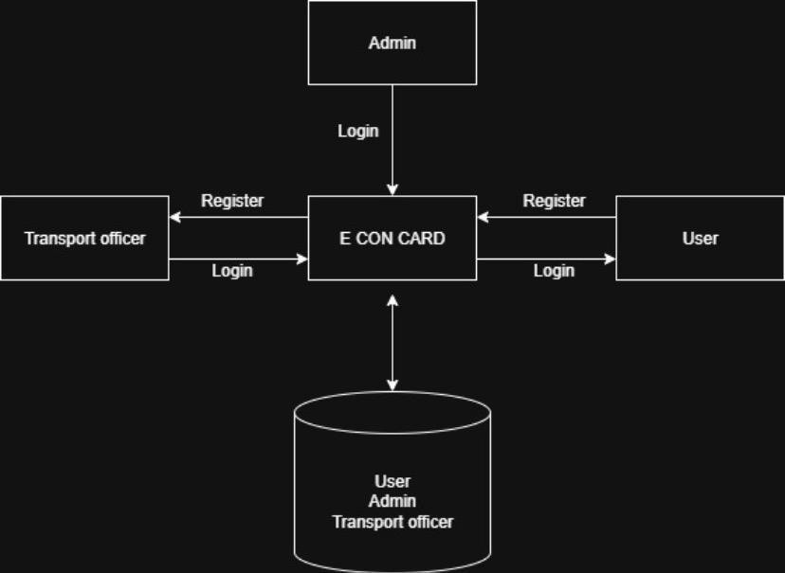

### *Figure 5.1 System Architecture*

#### 5.2 Presentation Layer (Frontend)

The presentation layer, also referred to as the frontend, serves as the primary interface through which all users Students, Admins, and Transport Officers interact with the Student Concession Card Management System. It is designed to be highly user-friendly, intuitive, and responsive, ensuring a seamless experience across different devices such as desktops, laptops, tablets, and smartphones. For students, the frontend allows secure registration and login, enabling them to access their personalized dashboard where they can submit concession card requests, upload supporting documents, and monitor the status of their applications in real time. Students can also receive notifications directly on the interface about approval, rejection, or pending status, and download approved digital concession cards conveniently without needing to visit any office physically.

Admins use the frontend to manage the system efficiently by monitoring student submissions, managing user accounts, assigning Transport Officers, and overseeing the entire approval workflow. Transport Officers interact with the same interface to review requests, verify eligibility criteria, and approve or reject applications. The frontend provides clear navigation, organized forms, and interactive elements to facilitate smooth and error-free operations for all user roles.

* Register and log in securely.
* Submit concession card requests.
* View notifications regarding the status of requests.
* Download approved digital concession cards.

Technologies used for the frontend include HTML, CSS, and JavaScript to create dynamic and interactive pages.

#### 5.3 Application Layer (Backend)

The backend of the Student Concession Card Management System is responsible for handling all the core functionalities that drive the system’s operations. It acts as the central processing unit, managing the communication between the frontend (user interface) and the database where all records are stored. The backend processes student actions such as registration, login, and concession card requests, ensuring that all input data is validated for accuracy, completeness, and security before being stored in the database. It also implements the system’s business rules, such as checking student eligibility, managing approval workflows, generating digital concession cards, and sending automated notifications to students regarding the status of their applications.

In addition, the backend maintains the logic for role-based access control, ensuring that only authorized users Students, Admins, and Transport Officers can perform their respective actions. It coordinates the workflow between modules, such as routing submitted requests from students to the Transport Officer for verification and then notifying the Admin about the system’s overall status. The backend also handles error management, security protocols, and transaction logging, which ensures data integrity, prevents unauthorized access, and allows for auditing or reporting. Technologies commonly used for the backend include Python (Django or Flask) which provide robust frameworks for handling server-side logic, routing, authentication, and integration with the database layer.

The backend ensures that the system operates smoothly, securely, and efficiently, making it the backbone of the Student Concession Card Management System. It guarantees that all processes from request submission to approval and digital card generation are executed correctly and consistently, providing a reliable and scalable environment for both students and administrative staff.

#### 5.4 Data Layer (Database)

The data layer of the Student Concession Card Management System serves as the foundation for storing and managing all essential information required for the smooth operation of the platform. This layer securely maintains records of student personal, academic, and transportation details, ensuring that all submitted data is validated and consistently stored for future use. It also keeps track of all concession card requests, including the status of each application whether pending, approved, or rejected along with any remarks provided by the Transport Officer or Admin. Additionally, the database stores Transport Officer and Admin account details, facilitating role-based access and enabling secure login and management of system functions.

Another critical function of the data layer is maintaining notification logs and digital concession card data, which allow the system to generate real-time alerts for students regarding their application status and to provide downloadable digital cards once approved. By using robust relational database management systems such as MySQL or PostgreSQL, the system ensures secure, reliable, and scalable storage of all information.These databasesprovide advanced features like data integrity enforcement, query optimization, transaction management, and backup mechanisms, making them suitable for handling large volumes of student and administrative data.

The data layer acts as the central repository that supports all operations of the system. It ensures that information is accurate, secure, and readily accessible for processing by the backend, while also enabling seamless interaction with the frontend interface. This structured and well maintained storage is crucial for the system’s efficiency, reliability, and scalability, allowing educational institutions to manage student concession cards digitally without errors or data loss.

#### 5.5 System Communication Flow

The communication flow of the Student Concession Card Management System demonstrates how information travels between users and system components to ensure seamless operations. The process begins when a student interacts with the frontend, performing actions such as registration, login, or submission of a concession card request. Once the request is submitted, it is transmitted securely to the backend, where the system validates the data, applies business rules, and stores all relevant information in the database. The Transport Officer then accesses the backend to retrieve submitted requests and conducts a thorough eligibility verification, examining student details, academic records, and transportation information. Upon completing the verification, the officer either approves or rejects the request, and the backend updates the database with the new status.

At the same time, the notification module communicates the outcome to the student in real time, informing them whether their request has been approved, rejected, or is still pending. This automated communication eliminates the need for manual follow-ups and ensures transparency in the approval process. The Admin plays a supervisory role throughout this flow, overseeing the activities of both students and Transport Officers, managing users, monitoring requests, and ensuring that the system functions efficiently without delays or errors. By maintaining a structured and continuous communication cycle between the frontend, backend, database, Transport Officer, Admin, and notification system, the platform guarantees accurate data exchange, timely notifications, and a smooth, transparent, and efficient process for all users involved**.**

#### 5.6 Security And Reliability

The Student Concession Card Management System is built with comprehensive security measures to safeguard sensitive student and administrative data while ensuring secure and uninterrupted operations. A key feature is role-based access control, which restricts functionalities based on the user’s role Students, Admins, or Transport Officers ensuring that only authorized personnel can perform specific actions. The system employs secure login and authentication mechanisms to prevent unauthorized access, and all passwords are stored using strong encryption techniques, adding an extra layer of protection. To defend against common cyber threats, such as SQL injection, cross-sitescripting (XSS), and data tampering, the system performs rigorous input validation and data sanitization. Furthermore, all data exchanges between the frontend and backend are encrypted to maintain confidentiality and integrity, ensuring that sensitive information cannot be intercepted or misused during transmission. Regular database backups safeguard student information, concession card requests, and historical records against accidental loss, corruption, or system failures.

Reliability is a critical aspect of the system’s design. The platform is structured using a modular architecture, separating the frontend, backend, and database layers, which enables efficient fault isolation and ensures smooth error handling without affecting the entire system. Automated notifications and real-time status updates reduce reliance on manual interventions, improving the accuracy of information and communication. Routine database maintenance and system monitoring further enhance operational stability, minimizing downtime and ensuring consistent performance. Additionally, redundant data storage and recovery mechanisms are implemented so that all records, including student applications and notifications, remain accessible even in the event of technical failures. By combining advanced security practices with high system reliability, the platform guarantees a trustworthy, efficient, and dependable environment for managing student concession cards, supporting daily operations without compromise

**CHAPTER-6**

## MODULES

### 6.1 User Module

The User Module is a key component of the Student Concession Card System that allows students to directly interact with the platform and perform all essential activities in an easy and digital manner. This module begins with a simple registration process, where students create an account by entering their personal details (name, age, contact information), academic details (institution, course, year), and transport-related information (travel route, station, or bus pass requirement). Once registered, students can securely log in using their username and password, ensuring that only authorized users can access the system. After logging in, students gain access to a user-friendly dashboard where they can submit concession card requests by filling out a form and uploading any required documents for verification. The system makes the process smooth and paperless, avoiding the need to stand in queues or fill out manual forms. One of the most helpful features of this module is the automatic notification system, which keeps students informed about the current status of their request. Whether the request is pending, approved, or rejected, the student receives timely updates without needing to visit the transport office.

Once the concession card request is approved by the admin or transport officer, students can download their digital concession card directly from the system. This digital card can be used for daily travel, making the process fast and convenient. By offering online registration, secure login, easy request submission, real-time status tracking, instant notifications, and digital card download, the User Module completely removes the need for manual paperwork and physical visits. It saves time, increases transparency, and provides a smooth and comfortable experience for students, making the entire concession card process more efficient and modern. Information, including contact details, academic records, and transportation preferences, ensuring that their profiles remain accurate and up to date. By integrating all functionalities in a single interface, the User Dashboard significantly reduces manual effort, saves time, and improves transparency. Its well-organized design ensures that students can perform tasks quickly and efficiently while staying informed about the status of their requests, ultimately enhancing the overall user experience and making the concession card process smooth, reliable, and convenient.

The User Dashboard serves as the central hub for students after logging into the concession card management system, providing a clear and organized view of all essential information in one place. It begins with a friendly, personalized welcome message that makes the user feel recognized. At the top, a simple navigation bar offers quick access to important sections such as Profile, Card details, Downloads, and Logout, ensuring smooth movement throughout the platform. The most important feature of the dashboard is the status notification panel, which clearly informs users whether their latest concession card request is approved, along with a visible download button for easy access to their approved cards. Below this, key statistics are displayed in neat information cards showing the total number of requests made, how many have been approved, and the date of the latest card approval. The layout is clean, visually appealing, and user-friendly, allowing students to quickly understand their progress and take necessary actions without confusion.the user dashboard acts as a smart control center where students can monitor their requests, view updates, and manage their concession cards efficiently.

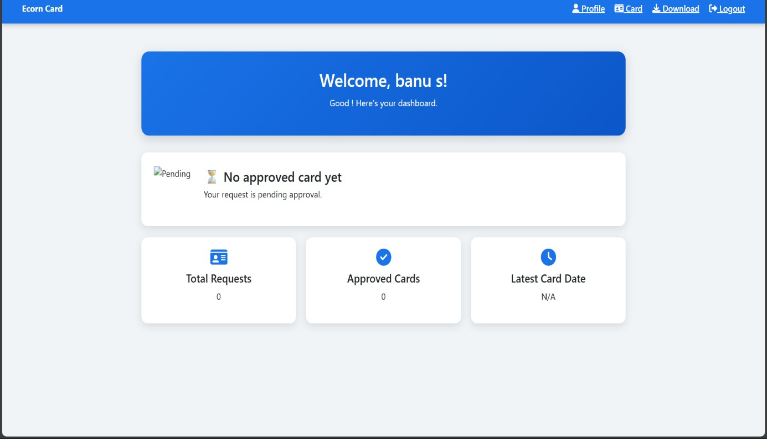

### *Figure 6.1 User Module*

#### 6.2 Admin Module

The Admin Module acts as the central command center of the Student Concession Card Management System, giving administrators full control over all system operations to ensure that the platform runs smoothly, securely, and efficiently. Admins hold the highest level of authority in the system and can manage all student-related information, including personal details (name, contact), academic information (institution, course, year), and transportation details (route, station, or bus pass type). By having access to this data, admins can monitor, verify, and validate the accuracy of the information submitted during registration or concession card requests, ensuring that the system is used correctly and only by eligible students. Another important responsibility of the admin is to manage Transport Officers, who play a key role in the request verification process. Through the Admin Module, admins can add new officers, update their roles or permissions, or remove inactive or unauthorized officers, ensuring that only trusted personnel handle the approval process. This helps maintain security and smooth coordination within the system.

The Admin Module also enables administrators to track, review, and monitor all concession card requests submitted by students. With a complete overview of pending, approved, and rejected applications, admins can ensure that each request is processed in a timely and transparent manner. In addition, the module controls the notification system, making sure students receive accurate and real-time updates about the status of their requests whether approved, rejected, or still pending. This reduces confusion, improves communication, and keeps students informed at every stage. Beyond daily operations, the Admin Module provides powerful auditing, reporting, and analytics tools. These tools allow admins to generate detailed reports on the number of applications received, approved, or rejected, track officer performance, analyze system usage trends, and detect any potential issues or delays in the process. By having these insights, admins can make better decisions, improve system efficiency, and optimize workflow. Admin Module ensures data integrity, accountability, and transparency across the entire platform. It minimizes manual workload, eliminates paperwork, prevents errors, and maintains a fully digital and well-organized concession card process. By overseeing user management, officer management, request processing, notifications, and reporting, the Admin Module guarantees that the system remains reliable, secure, and efficient for all stakeholders.

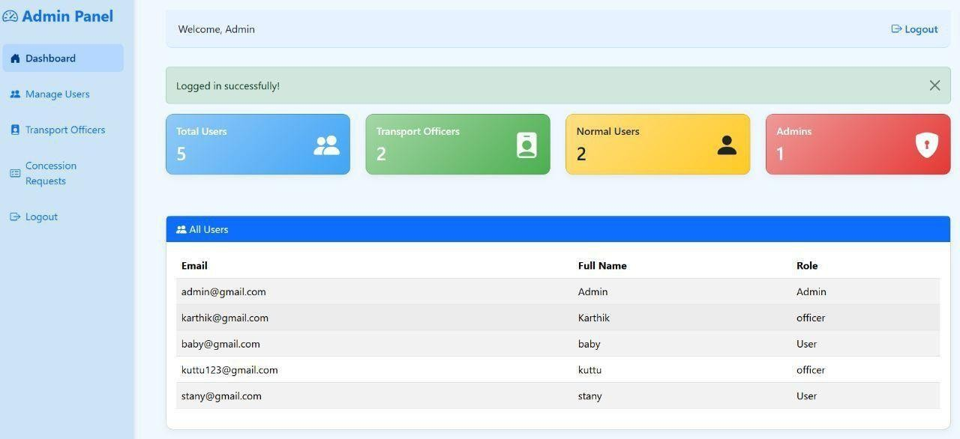

### *Figure 6.2 Admin Module*

#### 6.3 Transport Officer Module

The Transport Officer Module is responsible for verifying and managing student concession card requests to ensure that only eligible students receive concessions. Transport Officers review all submitted student details, including personal, academic, and transport-related information, and check submitted documents to confirm eligibility criteria. They can then approve or reject requests, which automatically updates the system and triggers notifications to inform students of the outcome. The module also allows officers to maintain records of all processed requests, including approved, rejected, and pending applications, ensuring accountability and transparency in the verification process. By managing requests efficiently, the Transport Officer Module reduces manual errors, prevents misuse of concession cards, and ensures that the concession process is fair, transparent, and fully digital. This module also supports reporting and tracking, enabling officers to monitor trends, identify recurring issues, and provide feedback to the Admin for system improvements.The Transport Officer Dashboard is a specialized interface designed to help transport officers manage the entire concession card verification process in a structured and time-efficient manner. It brings together all the tools and information that officers need, allowing them to work systematically without confusion or delay. As soon as the transport officer logs in, the dashboard presents a clear overview of all pending student requests, making it easy to identify which applications require immediate attention. Each request contains important details such as the student’s name, course, academic year, institution, and uploaded supporting documents, ensuring the officer has all necessary data in one place.

One of the main functions of the dashboard is to facilitate eligibility verification. Transport officers can carefully review the documents submitted by the student such as ID cards, proof of enrollment, or previous concession records and compare them with institutional data. Based on this evaluation, the officer has the authority to approve the request if it is valid or reject it if there are errors, missing details, or incorrect information. This structured approval process not only maintains fairness but also ensures that only genuine students receive concessions.

In addition to approving and rejecting requests, the dashboard allows officers to open and view complete student profiles. This feature helps them verify the student’s history, such as previously issued concession cards, the validity period of old cards, and any past rejections or misuse. By having access to this information, transport officers can maintain accuracy, consistency, and accountability in their decision-making. They can also keep proper records of processed requests, which becomes useful for generating reports, auditing, or submitting updates to the higher authorities or admin.

Another valuable feature of the Transport Officer Dashboard is its notification system. Whenever a student submits a new request or when the admin updates certain procedures or policies, the dashboard immediately displays notifications. This ensures transport officers remain informed in real time and can take quick action without missing any important updates.

This feature improves communication and helps maintain a smooth workflow between students, officers, and administrators.

By combining request management, student profile access, document verification, decision making tools, history tracking, notifications, and reporting in one unified interface, the Transport Officer Dashboard ensures that the approval process becomes smooth, transparent, accurate, and efficient. It reduces manual effort, avoids delays, and promotes fairness across all applications. Ultimately, this dashboard plays a crucial role in maintaining the integrity and reliability of the entire Student Concession Card System.

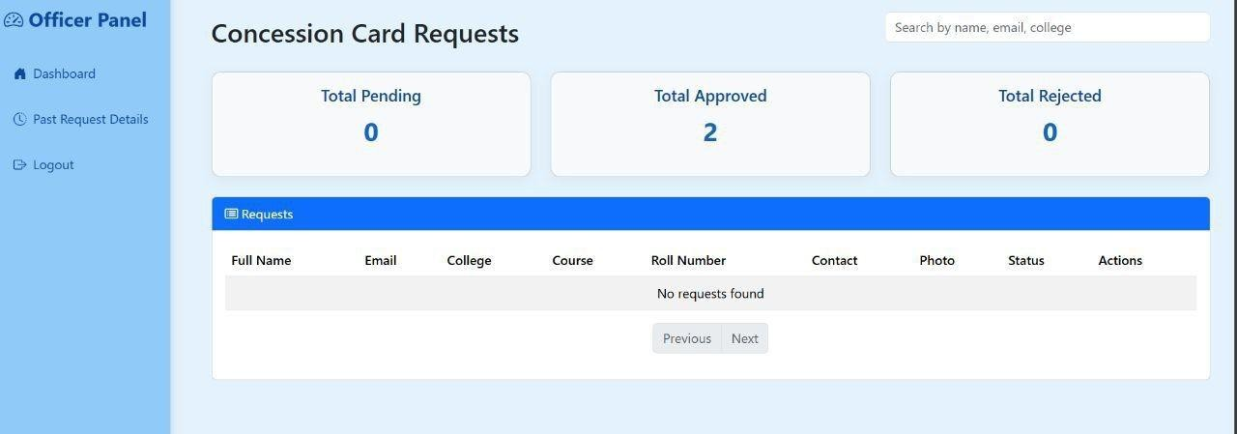

*Figure 6.3 Transport Officer Module*

**CHAPTER -7**

## DIAGRAMS

### 7.1 Data Flow Diagrams (DFD)

A DFD also known as a “bubble chart” has the purpose of clarifying system requirements and identifying major transformations that will become programs in system design. DFD consists of a series of bubbles joined by lines. The bubbles represent data transformations and the lines represents data flow in the system. A data flow diagram may be used to represent a system or software at any level of abstraction. DFD is a diagram that describes the flow of data and the processes that change or transform data throughout a system. It is a structured analysis and design tool that can be used or flowcharting in place of or in association with, information oriented and process-oriented system flowchart. When analyst prepare the DFD, they specify the user needs at a level of detail that virtually determines the information flow into and out of the system and the required data resources. This network is constructed by using a set of symbols that do not imply a physical implementation. The DFD reviews the current physical system, prepare input and output specification, specifies the implementation plan etc. Data Flow Diagrams represent one of the most ingenious tools used for structured analysis. Data Flow Diagram or DFD as it is shortly called is also known as a bubble chart. It has the purpose of clarifying system requirements and identifying major transformations that will become programs in system design. It is the major starting point in the design phase that functionally decomposes the requirements specifications down to the lowest level of detail. DFD consists of a series of bubbles joined by lines. The bubble represents data transformation and lines represent data flow in the system.

#### 7.1.1 Context Level or LEVEL 0 DFD

A Level 0 DFD is also called Context Diagram. It provides a high-level overview of the system or organization, illustrating the major processes and their interconnections. It represents the top - level view of data flow without delving into the internal workings of individual processes. The main purpose of a Level 0 DFD is to provide a conceptual understanding of how data moves through the system. It's important to note that a Level 0 DFD is often the starting point for creating more detailed DFDs. As the analysis progresses, additional levels (such as Level 1, Level 2, and so on) can be developed to further decompose the main process into sub processes and provide a more detailed representation of the system's functionality.

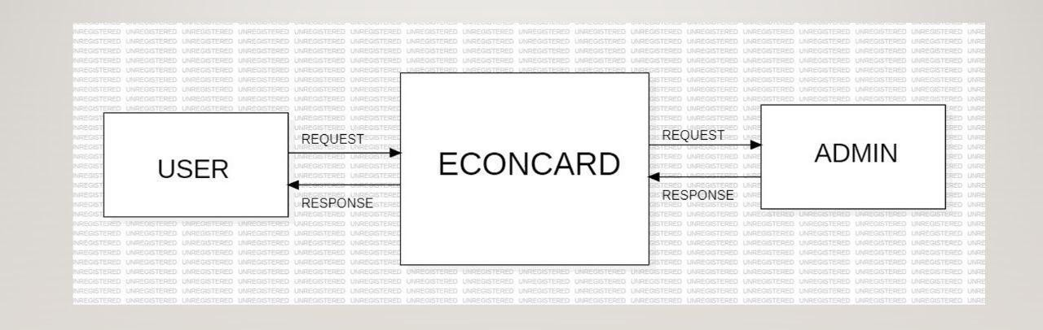

### *Figure:7.1 Level-0*

#### 7.1.2 LEVEL 1 DFD

A Level 1 DFD provides a more detailed view of the system or organization compared to the Level 0 DFD. It decomposes the processes identified in the Level 0 DFD into sub-processes, showing the data flows between them. Here, the main functions carried out by the system are highlighted as we break into its sub-processes. The purpose of a Level 1 DFD is to provide a more granular understanding of how data moves and is processed within the system. Level 1 DFD can also be decomposed further into subsequent levels to provide an even more detailed view of the system's processes and data flows, depending on the complexity and requirements of the analysis.

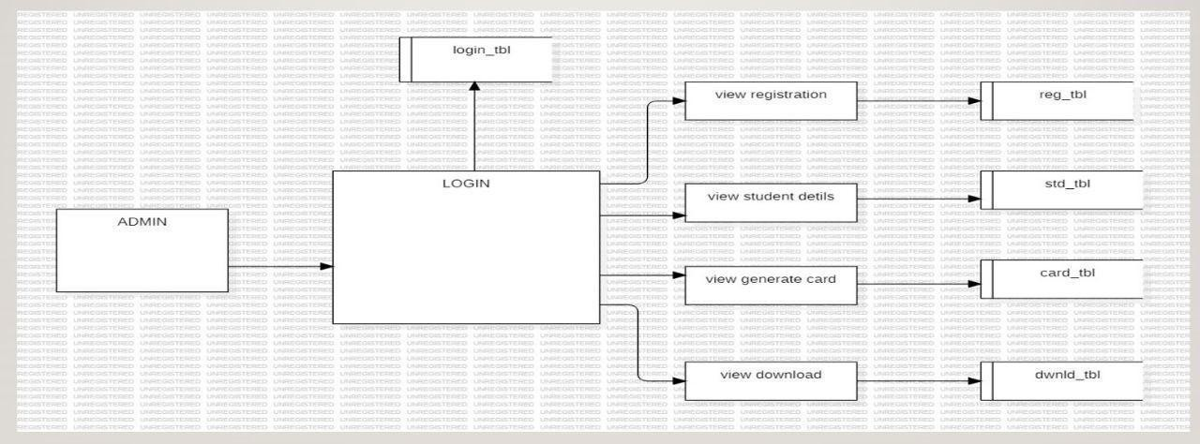

### *Figure:7.2 Level-1*

#### 7.1.3 LEVEL 2 DFD

The DFD Level 2 for the User Module provides a detailed view of how a student interacts with the system to manage their concession card requests. It breaks down the user’s activities into specific processes, showing how data flows between the student, system components, and databases. Initially, the student either registers or logs in. During registration, personal, academic, and transport-related information is captured, validated, and securely stored in the database. For login, the system verifies credentials to ensure secure access.

After login, the student submits a concession card request, which includes necessary details and supporting documents. This request is stored in the database and forwarded to the Transport Officer for verification. The DFD shows the continuous data flow that allows the student to monitor the status of their request. The system sends automated notifications about approval, rejection, or pending status. Once approved, the student can download the digital concession card from the system.

The DFD Level 2 highlights all internal processes such as registration, login verification, request submission, status tracking, notification handling, and digital card retrieval, as well as how these processes interact with the database. It ensures that all user actions are tracked and securely processed, providing a clear, stepby-step understanding of how the student module operates within the system.

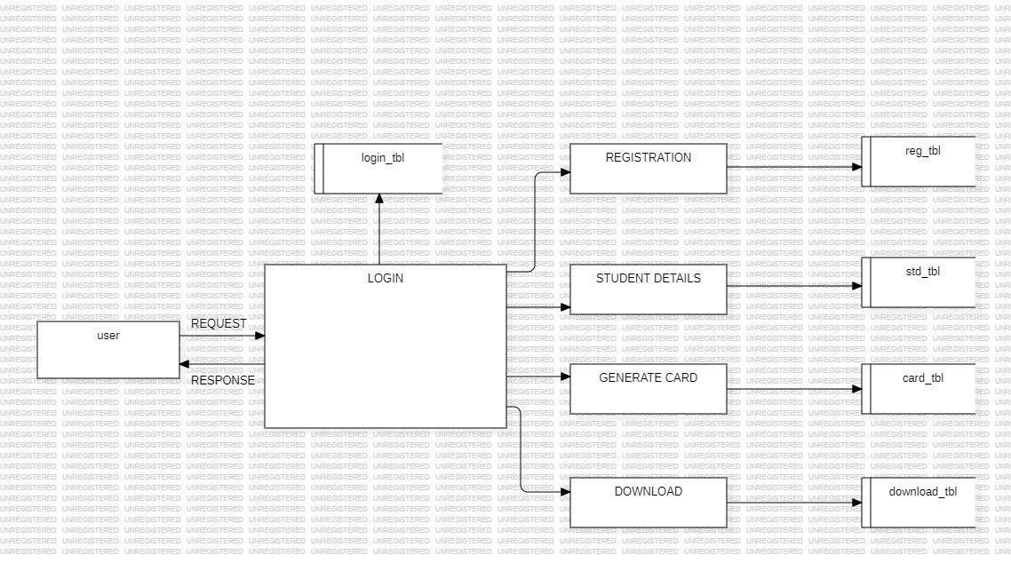 *Figure:7.3 Level 2*

#### 7.1.4 LEVEL 3 DFD

The Level 3 DFD for the Transport Officer module details the process of handling student concession card requests. The Transport Officer receives requests, verifies student eligibility based on academic and transport details, and then approves or rejects them. After the decision, the system updates the database and sends notifications to inform students about the status of their request. This ensures accurate, transparent, and timely processing of all concession card applications. The Level 3 DFD for the Transport Officer module details the process of handling student concession card requests. The Transport Officer receives requests, verifies student eligibility based on academic and transport details, and then approves or rejects them. After the decision, the system updates the database and sends notifications to inform students about the status of their request. This ensures accurate, transparent, and timely processing of all concession card applications.

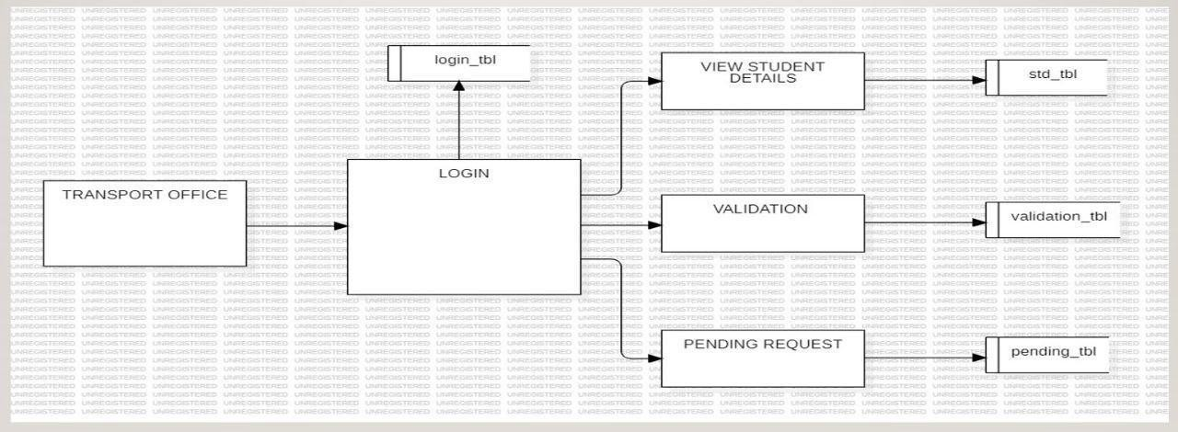

### *Figure:7.4 Level-3*

#### 7.2 Use Case Diagram

The Use Case Diagram for the Student Concession Card Management System illustrates the interaction between the system and its primary actors, which include Students, Transport Officers, and Admins. Students can register on the platform, securely log in, submit concession card requests, track the status of their applications, and download approved digital cards. Transport Officers are responsible for verifying student eligibility, reviewing the submitted requests, and approving or rejecting them. Admins oversee the entire system by managing user accounts, adding or removing Transport Officers, monitoring requests, and ensuring notifications are delivered accurately. The diagram visually represents these functionalities and clearly identifies how each actor interacts with different system processes. It serves as a highlevel representation of the system’s functional requirements, helping developers and stakeholders understand the flow of actions, responsibilities of each actor, and the overall operation of the system.

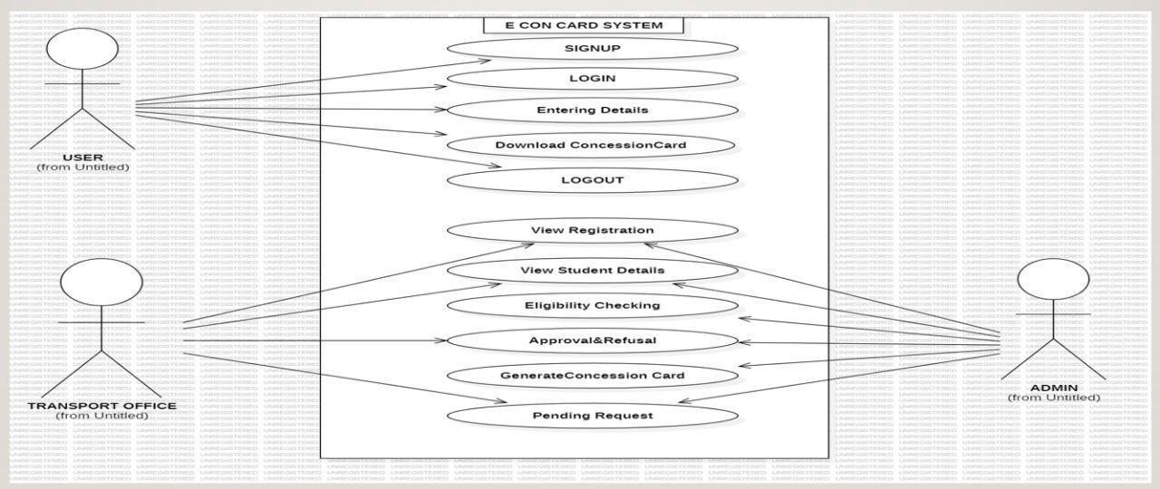

### *Figure:7.5 Use Case Diagram*

#### 7.3 Sequence Diagram

The Sequence Diagram for the Student Concession Card Management System depicts the stepby-step interaction between the actors and the system during a typical concession card request. It begins with the student logging into the system and submitting a concession card request, which includes filling personal details and uploading necessary documents. The system receives the request and stores the information in the database. Next, the Transport Officer retrieves the request for verification, checks the eligibility criteria, and updates the status as approved or rejected. Once the status is updated, the system triggers a notification to inform the student about the outcome. If the request is approved, the student can download the digital concession card. The diagram clearly shows the sequence of messages exchanged between the student, system, Transport Officer, and database, illustrating the flow of operations in chronological order. This helps in understanding the internal processing logic and ensures that all interactions are accurately captured for implementation.

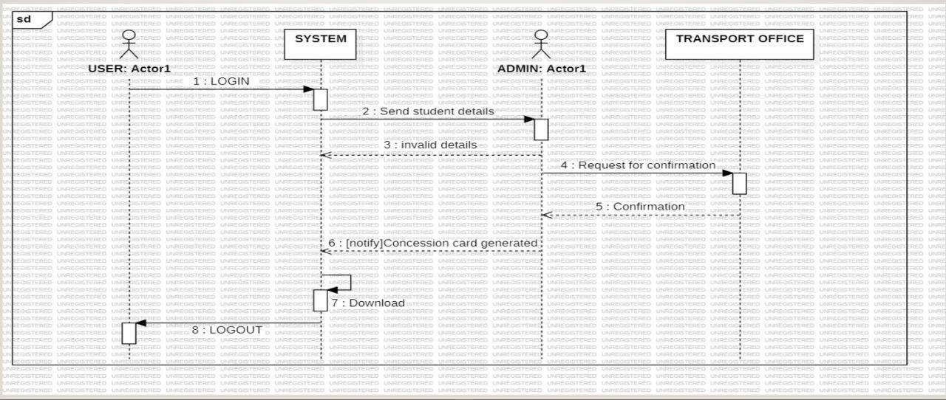

### *Figure:7.6 Sequence Diagram*

#### 7.4 Class Diagram

The Class Diagram for the Student Concession Card Management System represents the static structure of the system, showing the classes, their attributes, methods, and the relationships between them. The main classes include User (Student), Admin, Transport Officer, Concession Request, and Notification. The User class contains attributes such as name, student ID, email, and password, with methods for registration, login, submitting requests, and downloading digital cards. The Admin class includes methods to add Transport Officers, monitor requests, and manage users. The Transport Officer class has attributes for officer ID and methods for verifying requests, approving or rejecting them. The Concession Request class stores details of each request, including status and submission date, while the Notification class handles sending alerts to students regarding the status of their requests. This diagram provides a clear blueprint of the system’s objects and their interactions, helping developers understand the structure, responsibilities of each class, and the relationships needed to implement the system effectively.

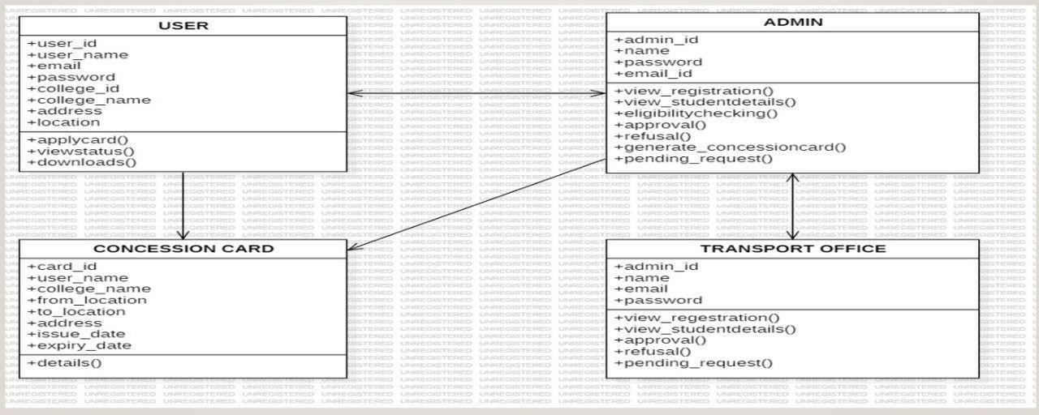

### *Figure:7.7 Class Diagram*

#### 7.5 Activity Diagram

Activity Diagram provides a clear visual representation of how different modules interact dynamically, the decision points within the system, and how data flows securely between users, officers, and system databases. It demonstrates the step-by-step progression of activities, the role of automation in reducing manual intervention, and how the system maintains transparency, efficiency, and accuracy throughout the concession card management process The Activity Diagram for the Student Concession Card Management System represents the workflow and sequence of actions involved in managing student concession card requests. It visually captures the dynamic behavior of the system, showing how students, Transport Officers, and Admins interact with the system through different processes. The activity starts with student registration or login. A new student first fills out personal, academic, and transportation-related information, which is validated by the system and stored securely in the database. Existing students log in by providing credentials, which are verified to ensure secure access. After successful login, the student can submit a concession card request by entering relevant details and uploading required documents. The system saves the request and updates the database to maintain a record of the submission. Once the request is submitted, the workflow moves to the verification stage, where the Transport Officer reviews the application. The officer checks the details, validates supporting documents, and ensures that the student meets eligibility criteria such as enrollment status and commuting distance. Based on this verification, the Transport Officer can either approve or reject the request. Each decision triggers an automated notification to the student, informing them of the current statuswhether pending, approved, or rejected. If the request is approved, the workflow continues to the digital concession card generation process. The system creates a card containing essential details such as the student’s name, photograph, institution, validity period, and unique ID. The student can then download or print this digital card for use in public transportation. Throughout this process, Admin oversight ensures that all activities are monitored for accuracy, security, and proper workflow management. The Admin can review system logs, manage user accounts, and ensure notifications and approvals are processed correctly. The Activity Diagram also highlights parallel processes, such as sending notifications while the Transport Officer is reviewing the application, and updating the database simultaneously. It emphasizes the sequential flow of operations from registration, request submission, verification, notification, to digital card generation, ensuring a smooth, automated, and user-friendly experience. Activity Diagram provides a clear visual representation of how different modules interact dynamically, the decision points within the system, and how data flows securely between users, officers, and system databases. It demonstrates the step-by-step progression of activities, the role of automation in reducing manual intervention, and how the system maintains transparency, efficiency, and accuracy throughout the concession card management process.

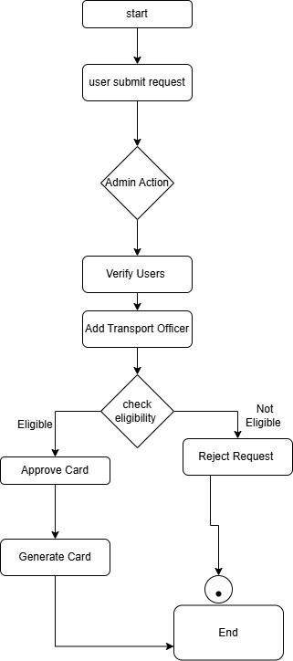

*Figure :7.8 Activity Diagram*

**CHAPTERS -8**

## TESTING

### 8.1 Testing

Testing plays a crucial role in ensuring the Student Concession Card System works accurately, securely, and efficiently for all users such as students, admins, and transport officers. The project undergoes different types of testing to verify each function of the system. Unit testing is performed to check individual features like user registration, login, request submission, and notification generation to ensure each module works correctly on its own. After that, integration testing is conducted to verify the smooth flow of data between modules—for example, the student submitting a request, the admin viewing it, and the transport officer approving it. System testing evaluates the entire application to confirm that all features meet the project requirements and perform well in real-world scenarios. User acceptance testing (UAT) is also carried out to make sure the system is user-friendly and meets the needs of students and staff. Additionally, security testing ensures that sensitive student data is protected, and only authorized users can access the system. Through all these testing stages, the project ensures reliability, accuracy, and a smooth user experience before final deployment.

**Testing principles are:**

* All tests should be traceable to customer requirements
* Testing should be planned long before the testing begins
* Testing should begin “in the small” and progress towards testing “in the large”.
* Exhaustive testing is not possible
* To be most effective, testing should be conducted by an independent third party.

**Testing objective are:**

* Testing is the process of executing a program within the intent of finding an error.
* A good test case is one that has high probability of finding an as-yet-undiscovered error.
* A successful test is one that un covers an as yet-undiscovered error

There are various testing strategies available to accommodate from low-level testing to high-level testing as discussed below.

### Test Plan

Testing is the major quality control measure employed during software development. In the project, the first test considered is the unit testing. In this unit testing, each module of the system is tested separately. This is carried out during programming stage itself. Each module should work satisfactory as regard from the module.

After the entire module are checked independently and completed then the integration testing is performed to check whether there are any interface errors. Then those errors are verified and corrected and also the security test is performed to allow only authorized persons to this system. Finally, the validation testing is performed to validate whether the customer requirements are stratified are not.

### 8.2 Unit Testing

Unit testing is a software testing technique in which individual components or modules of a system are tested independently to ensure that each unit functions correctly according to its design and specifications. In the context of the Student Concession Card Management System, unit testing focuses on validating the core functionalities of each module, such as the User Module, Admin Module, Transport Officer Module, Notification Module, and Digital Card Generation Module. For instance, in the User Module, unit tests verify that student registration correctly validates input data, stores information in the database, and handles login authentication. Similarly, the Transport Officer Module is tested to ensure that eligibility verification, approval, and rejection workflows operate accurately and update the system consistently. Unit testing also checks the Notification Module, confirming that automated alerts are sent correctly when a student’s request status changes. The Digital Card Generation Module undergoes tests to ensure that approved cards contain accurate student information and are downloadable without errors. These tests are often automated using testing frameworks available in the development environment, such as unit test or py test in Python, allowing repetitive testing of functions with different inputs to detect edge cases and unexpected behaviors. The main objective of unit testing is to identify and fix bugs at the earliest stage of development, which reduces the risk of system failures during integration or deployment. It enhances code reliability, ensures that each module meets its intended functionality, and provides a foundation for more extensive integration and system testing. By performing thorough unit testing, the Student Concession Card Management System ensures that all modules work correctly in isolation, which ultimately contributes to the overall stability, security, and efficiency of the platform, providing a seamless experience for students, Admins, and Transport Officers

### 8.3 Validation Testing

Validation testing is a crucial software testing technique that ensures the Student Concession Card Management System operates according to the user’s expectations and requirements. Unlike unit testing, which focuses on individual components, validation testing examines the system as a whole after integration testing has been completed. At this stage, all modules such as the User Module, Admin Module, Transport Officer Module, Notification Module, and Digital Card Module have been integrated, and any interfacing errors or inconsistencies between modules have been identified and corrected. The purpose of validation testing is to confirm that the system meets its intended functionality, performs reliably, and fulfills the requirements specified by the end-users, such as smooth registration, accurate eligibility verification, timely notifications, and successful digital card generation.During validation testing, real-world scenarios are simulated to verify that the system behaves as expected when students submit

requests, Transport Officers approve or reject applications, and Admins monitor overall operations. This includes testing the accuracy of notifications, security of login credentials, integrity of database updates, and download functionality of approved digital cards. Validation testing ensures that the final system is not only technically correct but also user-friendly, efficient, and dependable for daily use. By thoroughly validating the system after integration, developers can guarantee that the Student Concession Card Management System meets both functional and non-functional requirements, providing a reliable and satisfactory experience for all users.

The error detecting during this testing is

* Incorrect Function
* Input Condition Errors
* Database Error
* Performance Error
* Initialization and Interface Error

**8.4 Regression Testing.**

Regression testing is a software testing practice that ensures an application still functions as expected after any code changes, updates, or improvements. Regression testing is responsible for the overall stability and functionality of the existing features. Whenever a new modification is added to the code, regression testing is applied to guarantee that after each update, the system stays sustainable under continuous improvements. Changes in the code may involve dependencies, defects, or malfunctions. Regression testing targets to mitigate these risks, so that the previously developed and tested code remains operational after new changes. Generally, an application goes through multiple tests before the changes are integrated into the main development branch. Regression testing is the final step, as it verifies the product behaviour as a whole.

Regression testing is a type of software testing performed to ensure that recent changes or updates in the system do not negatively affect the existing functionalities. In the context of the Student Concession Card Management System, regression testing is crucial whenever enhancements, bug fixes, or updates are made to modules such as User Registration, Concession Card Request, Transport Officer Verification, Notifications, or Digital Card Generation. The goal is to confirm that previously working features continue to function correctly after modifications. For example, if a new validation rule is added for student registration or the notification format is updated, regression testing checks that the login process, card submission workflow, and approval notifications still operate as expected. This type of testing ensures the stability and reliability of the system over time, preventing unintended side effects from code changes. Automated test scripts are often used in regression testing to repeatedly verify that critical workflows, such as request submission, eligibility verification, and digital card downloads, remain functional after updates. By conducting thorough regression testing, developers can maintain the integrity of the Student Concession Card Management System, ensuring that updates enhance the system without introducing errors, thereby providing a consistent and dependable experience for all users.

### 8.5 Integration Testing

Integration testing is a critical phase in the software development lifecycle that focuses on verifying the interactions and proper functioning of combined modules within a system. After individual components are validated through unit testing, integration testing ensures that these modules work together seamlessly and that data flows correctly across the system. The main objective is to detect interface defects, inconsistencies, and interaction problems that may not be visible when modules are tested in isolation. Several approaches are used in integration testing, including Big Bang, where all modules are tested together at once, and Incremental Testing, where modules are integrated and tested gradually. Incremental testing can further be classified into Top-Down, Bottom-Up, and Sandwich (Hybrid) approaches, which use stubs and drivers to simulate missing modules. Integration testing not only verifies the correctness of interfaces and data exchange but also ensures that the overall system behaves as expected under different scenarios. It helps in identifying and resolving issues early, thereby reducing the cost and complexity of fixing defects at later stages. Although it requires careful planning, coordination among development teams, and sometimes additional test tools, integration testing is essential for delivering a robust, reliable, and efficient software system that meets user requirements and functions smoothly in real-world environments. It is widely applied across various software domains, including web applications, mobile apps, and enterprise systems, making it an indispensable part of quality assurance.

### 8.6 Acceptance Testing

Acceptance Testing is the final and most important stage of software testing, carried out to ensure that the developed system meets all the specified requirements and expectations of the client or end users. It acts as a bridge between the development phase and the actual deployment of the software. The main objective of acceptance testing is to validate that the software is ready for real-world use and can perform all the required business functions correctly. Unlike other testing stages performed by developers and testers, acceptance testing is usually done by the customer or users to confirm that the system fulfills their needs and provides the desired results. This testing focuses on checking the functionality, usability, and overall behavior of the system from the user’s point of view. It helps identify any missing features, usability issues, or functional errors that may have been overlooked during earlier testing stages. Acceptance testing also ensures that the software works well in the user’s actual environment, including hardware, network, and data conditions. Once the software passes this testing phase, it is formally accepted by the customer and becomes ready for deployment or release.

There are two major types of acceptance testing: Alpha testing and Beta testing. Alpha testing is conducted in the developer’s environment by internal users or a selected group of testers. It helps detect minor issues before the product reaches the customer. Beta testing, on the other hand, is done in the real user environment by actual end users. It provides valuable feedback on performance, user experience, and reliability before the final release.

Acceptance testing is crucial because it gives confidence to both the developer and the client that the software product is complete, stable, and meets the business goals. If the system fails in this phase, it is sent back for correction and improvement. Therefore, acceptance testing ensures that the final product delivered to the customer is of high quality, user-friendly, and

ready for practical use in real-life scenarios.

**CHAPTER-9**

## ADVANTAGES & DISADVANTAGES

### 9.1 Advantages

* Digital Process: Eliminates manual paperwork and reduces dependency on physical forms.
* Time-Saving: Students can apply for concession cards online without visiting offices.
* Real-Time Notifications: Keeps students updated instantly about request status.
* Secure System: Role-based access ensures that only authorized personnel can access sensitive data.
* Efficient Approval Process: Transport Officers can verify and approve/reject requests quickly.
* Record Maintenance: Maintains detailed digital records of all requests for future reference.
* Transparency: Students can track the status of their applications at any time.
* Convenience: Digital cards can be downloaded and used for daily travel without paper cards.
* Reduced Errors: Automated data validation reduces errors in registration and request submission.
* Scalable System: Can be expanded for online renewals, reporting, analytics, or mobile app integration.
* Environment-Friendly: Reduces the use of paper, promoting sustainable practices.
* User-Friendly: Simple interface for students, Admin, and Transport Officers ensures easy navigation.

### 9.2 Disadvantages

* Internet Dependency: Requires an active internet connection to access the system.
* Technical Knowledge: Students or staff with low digital literacy may face difficulty using the system.
* System Maintenance: Requires regular updates and maintenance to prevent bugs or security issues.
* Initial Setup Cost: Developing and deploying the system may require initial investment in software and servers.
* Data Security Risk: Although secure, any online system is potentially vulnerable to cyber threats if not properly maintained.

**CHAPTER-10**

## RESULT

The Student Concession Card Management System successfully achieves the objective of digitizing and automating the traditional process of issuing and managing student concession cards. The implementation of this system has resulted in a significant reduction in manual effort and processing time. Students no longer need to fill out physical forms or visit administrative offices repeatedly; instead, they can register online, submit concession card requests, and track application status through the system’s intuitive dashboard. The system validates the student’s personal, academic, and transportation information at the time of submission, ensuring accuracy and reducing errors. Once approved by the Transport Officer, students can immediately download their digital concession cards, which can be used for travel without the need for paper-based cards. This feature enhances convenience and ensures a contactless, ecofriendly, and efficient process for students.

From an administrative perspective, the system provides Admins with comprehensive oversight of all student requests and user accounts. Admins can monitor the status of applications, add or remove Transport Officers, and ensure smooth workflow management. The Transport Officer module allows officers to verify student eligibility, approve or reject requests, and maintain a detailed record of all applications, which improves accountability and reduces the chances of fraudulent submissions. The integration of automated notification services ensures that students are informed immediately about the status of their requests, enhancing transparency and reducing delays caused by manual follow-ups. The results of deploying this system also demonstrate significant improvements in efficiency and reliability. The three-tier architecture comprising the frontend, backend, and database layers ensures smooth communication between components, secure data storage, and faulttolerant operations. For example, student registration and login are handled efficiently through the frontend, while the backend processes all business logic such as eligibility verification, approval workflows, and notifications. The database securely stores all student, Admin, and Transport Officer data, along with historical request records and digital card information. During testing, the system consistently handled multiple concurrent requests without data loss or performance degradation, indicating high scalability and reliability.

Another key outcome is the system’s role-based security implementation, which protects sensitive data and ensures that only authorized users can perform specific functions. Password encryption, secure login protocols, and input validation prevent unauthorized access and maintain data integrity. The system’s design also supports backup and recovery mechanisms, ensuring that all records are preserved even in the event of technical failures. As a result, both students and administrators can rely on the platform for daily operations without concerns about data loss or security breaches.

The deployment of this system also leads to a better user experience and satisfaction. Students benefit from a simplified and streamlined application process, immediate feedback on their requests, and access to digital cards anytime, anywhere. Transport Officers and Admins experience reduced administrative workload, improved tracking of student requests, and the ability to maintain organized and verifiable records. Moreover, the system promotes environmental sustainability by eliminating the need for paper-based concession cards and forms.

In addition to operational benefits, the system provides analytical advantages. Admins can generate reports regarding the number of applications submitted, approved, and rejected, allowing them to identify trends, manage resources effectively, and make informed decisions. Similarly, Transport Officers can analyze the data to verify compliance with eligibility criteria and identify potential irregularities. The combination of digital records, reporting tools, and automated notifications ensures a transparent, accountable, and well-organized concession card management process.

In conclusion, the results of implementing the Student Concession Card Management System highlight enhanced efficiency, improved transparency, reduced administrative workload, and better user satisfaction. The system successfully bridges the gap between traditional manual processes and modern digital solutions, providing a reliable, secure, and user-friendly platform for managing student concession cards. By streamlining workflows, securing sensitive data, and enabling instant access to digital cards, the system demonstrates a significant improvement over conventional methods. The results confirm that the platform is not only technically robust but also practical, scalable, and adaptable for future enhancements, such as mobile integration, online card renewals, and advanced reporting. the project validates that digital transformation in student transportation management .

**CHAPTER-11**

### CONCLUSION & FUTURE SCOPE

The Student Concession Card Management System has been successfully designed and implemented to streamline the process of issuing concession cards to students who rely on public transportation. Traditionally, the concession card process involved a significant amount of manual paperwork, physical visits to administrative offices, and long waiting periods, which were not only time-consuming but also prone to errors and mismanagement. By transitioning to a fully digital and automated system, this project addresses all the limitations of the conventional method, providing a fast, reliable, and user-friendly platform for students, Transport Officers, and administrators alike.

One of the key achievements of this project is the integration of role-based modules, including the Student (User) Module, Admin Module, Transport Officer Module, and Notification Module. Each module is designed to perform specific tasks efficiently while maintaining data integrity, security, and transparency. Students can now register online, submit concession card requests, and receive real-time notifications regarding the status of their applications. They can also download the digital card immediately upon approval, which eliminates the need for physical cards and reduces dependency on manual processes. This functionality significantly improves student convenience, reduces administrative workload, and ensures that all actions are traceable and recorded digitally.

From the perspective of administrators and Transport Officers, the system provides a centralized dashboard for efficient management. Admins have the capability to manage student information, add or remove Transport Officers, and monitor all concession card requests in real time. Transport Officers can easily verify student eligibility, approve or reject requests, and maintain accurate records for accountability. The backend ensures that every transaction and status update is accurately reflected in the database and that students receive timely notifications about their applications. This organized workflow prevents errors, reduces delays, and promotes fair and transparent handling of all concession requests. Another important aspect of the system is security and reliability. The application implements role-based access control, secure login authentication, password encryption, and input validation to protect sensitive information and prevent unauthorized access. Regular database backups and fault-tolerant design ensure that student records and system data are safe even in the event of technical failures. This reliability ensures that the system can be trusted for daily operations and can handle a large number of users simultaneously without compromising performance.

The system architecture, based on a three-tier design (Presentation Layer, Business Logic Layer, and Data Layer), ensures scalability and maintainability. The modular design allows future enhancements, such as integration with mobile applications, online payment gateways, automated reporting, or analytics tools, without affecting the current system functionality. This makes the system flexible and adaptable to evolving requirements in the field of student transportation management.

The Student Concession Card Management System demonstrates the practical application of modern web technologies to solve real-world problems. By digitalizing the concession card process, the project achieves a balance between convenience for students and efficient administration for officials. The system reduces paperwork, minimizes human errors, and ensures that concession eligibility verification is performed consistently and transparently. It also encourages the use of digital processes within educational institutions and transportation departments, which can serve as a model for other similar projects aiming to digitize student services.

The Student Concession Card Management System has a strong foundation in digitalizing the traditional manual process, but there are several opportunities to enhance its capabilities in the future. One of the major future improvements is the integration of mobile applications for Android and iOS. A dedicated mobile app would allow students to apply, track status, and display the digital concession card directly on their smartphones without needing a printed card. This improves accessibility, convenience, and real-time engagement. Additionally, features such as push notifications, biometric login, and in-app document upload can improve the user experience significantly.Another important future enhancement is the integration of QR code and NFC-based smart card systems for easier authentication and verification. Transport authorities could scan the QR code or tap NFC-enabled digital cards to instantly verify the validity of the concession. This would eliminate fake cards, reduce misuse, and promote transparent validation. The system could also be connected to Smart Transport Systems or Eticketing platforms, enabling automatic fare deduction for students and seamless travel experiences.

In the future, the system can include online renewal and auto-renewal features to help students renew their concession cards without resubmitting full details. A reminder or auto-renewal mechanism would ensure continuity without delays. Additionally, the analytics and reporting module can be expanded to generate insights for administrators such as usage statistics, peak request times, transport demand, and student categories helping in decision-making and future planning.

To further improve reliability and scalability, the system can be migrated to cloud infrastructure. Cloud hosting would support high traffic, ensure better backup, enable remote access, and reduce maintenance costs. Advanced data security measures, such as multi-factor authentication, blockchain-based records, and real-time intrusion detection, can be implemented to protect personal data and maintain trust. Moreover, AI-based document verification and eligibility checking can automate approval processes by recognizing patterns and validating information without full manual intervention.

At a larger scale, this system can be integrated with government transport systems, universities, and regional bus/train authorities to form a centralized concession platform. Students from different institutions could use one unified system, improving interoperability and reducing administrative overhead. Multi-language support, chatbot assistance, and accessibility features for differently-abled users can also enhance inclusivity and usability.

**APPENDICES**

## Admin.py

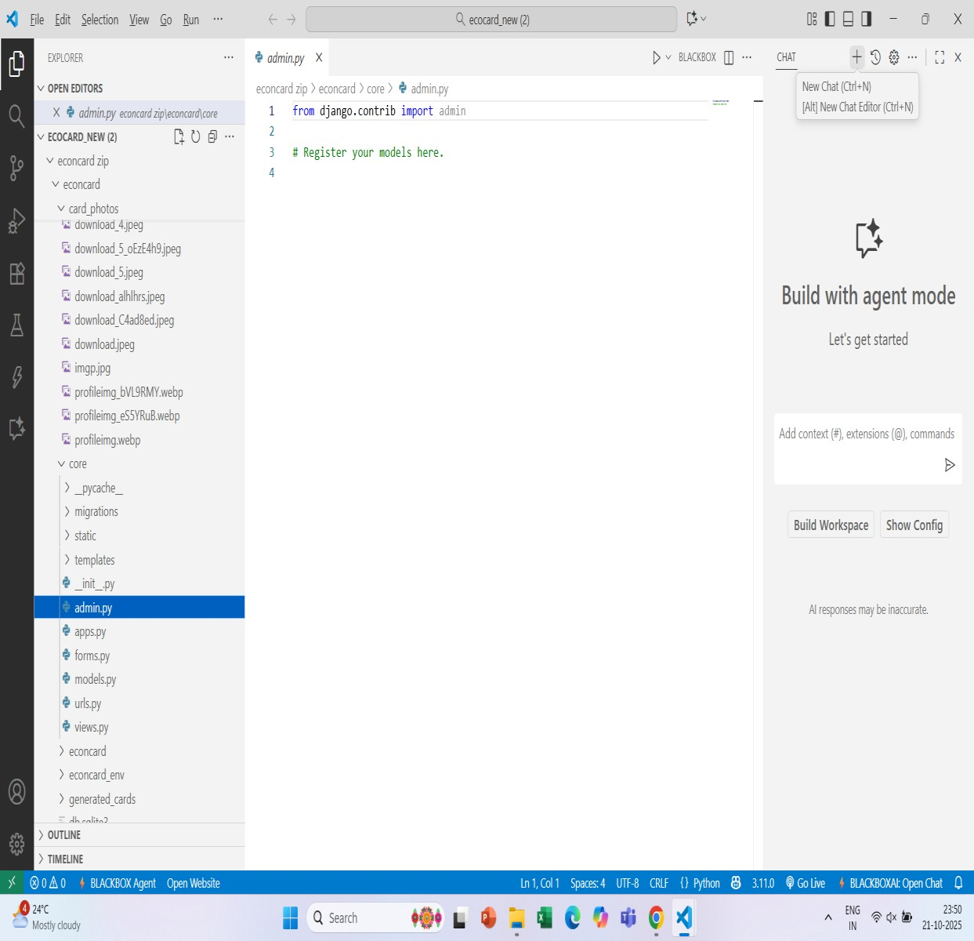

### Forms.py

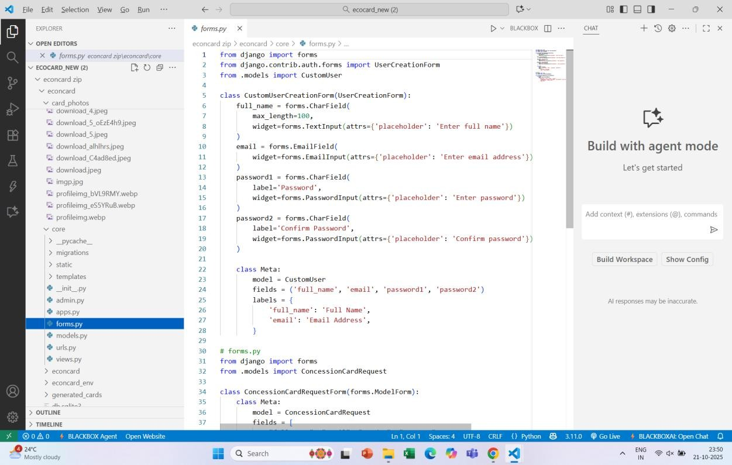

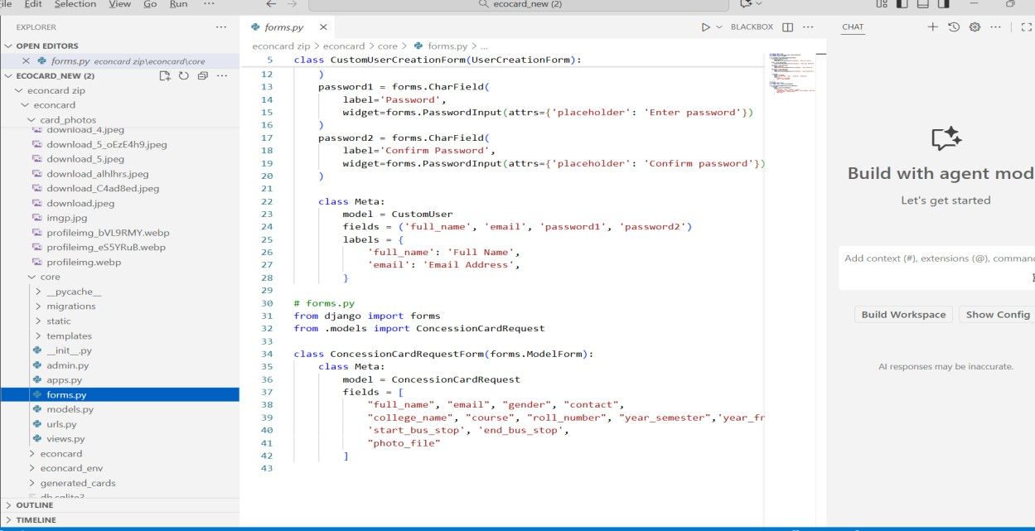

### Models.py

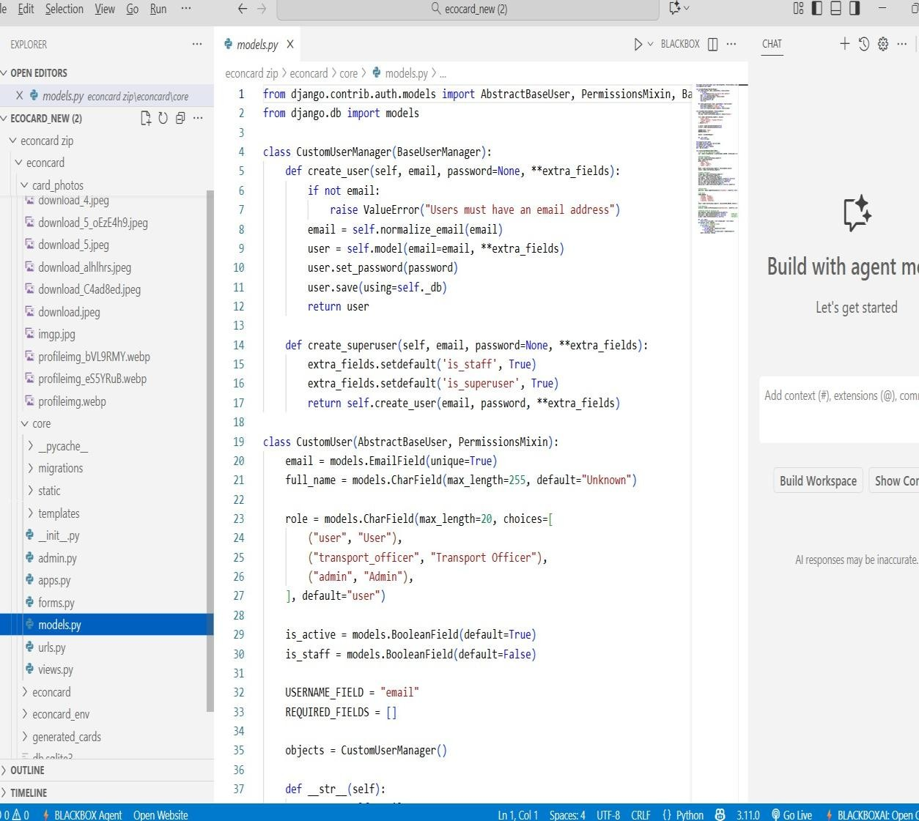

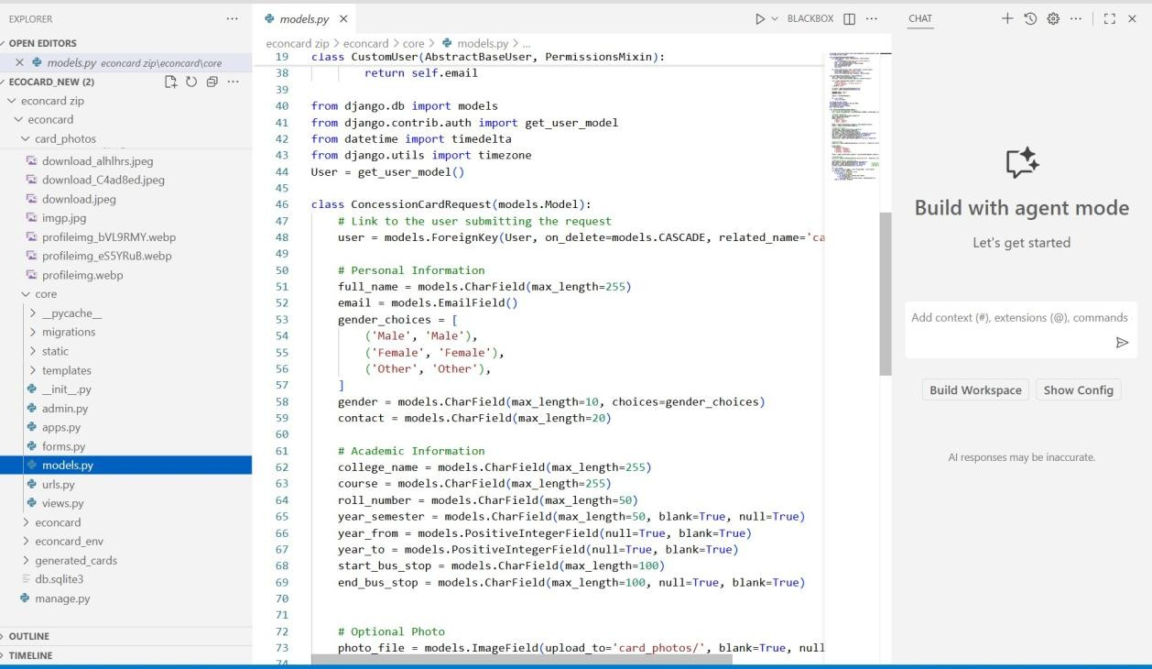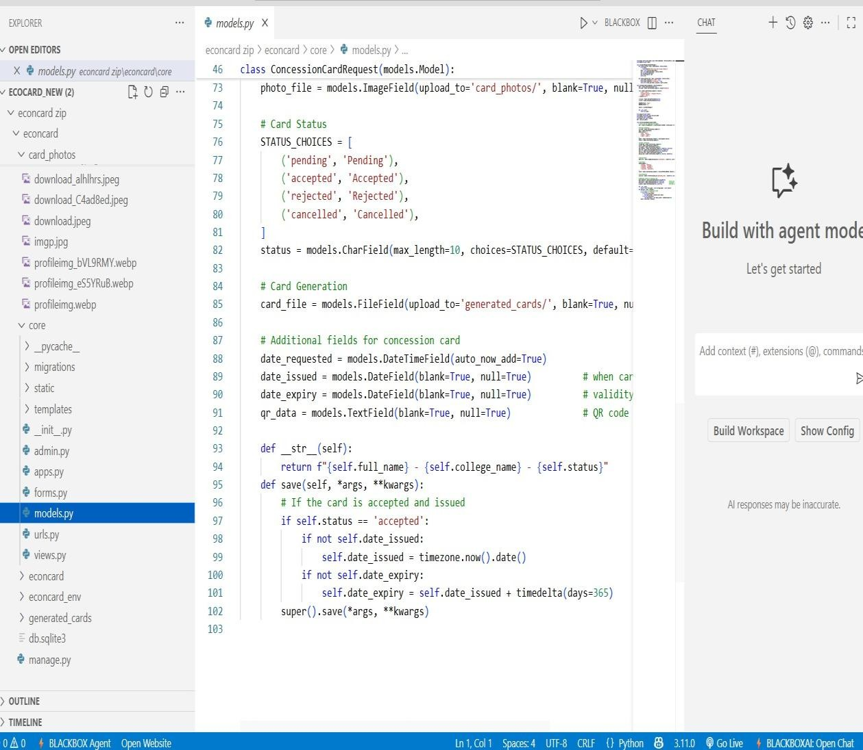

## REFERENCES

[1]¹ Providing Discounted Transit Passes to Younger University Students: Are there effects on

Public Transit, Car and Active Transportation trips to University[Ugo Lachapelle, Kevin

Manaugh,Simon Hamelin-Pratte (2022)]

[2]² NJ Transit Student Discount Program Expands to Include Part-Time Students

[NJ TRANSIT (2023)]

[3]³ KSRTC Card System[Vishnu R, Prof. Rajitha P.R (2023)]

[4]⁴ Digitalizing the Student Concession Card[Jishma Jayesh, Anuraj T R, Anu Joseph (2024)]

[5]⁵ Smart Card-Based Public Transportation System for Students[R. Sharma & A. Patel (2020)]

[6]⁶ Digital Concession Card Management System for Educational Institutions

[Sharma, R. & Kulkarni, S. (2022)]

[7]⁷ Smart Transport Pass Issuance Using QR-Code Based Digital Identity[Banerjee, A.(2022)]

[8]⁸ Web Based Student Pass Issuance and Verification System

[Sharma, R & Gupta (2021)]

[9]⁹ Smart Digital Concession Card with Tap-and-Pay Technology for Students

[Patel, S. & Deshmukh, R. (2021)]

[10]¹⁰ Smart Digital Concession Card with Tap-and-Pay Technology for Students

[Khan, A. & Verma, P. (2024)]

1. M. L. Fernandez and P. Gupta, “Smart Mobility Solutions for Student Transportation

Using QR and NFC Technologies,” *International Journal of Smart Infrastructure and Transportation Systems*, vol. 5, no. 2, pp. 45–53, 2023

1. R. Banerjee, S. Patel, and K. Kulkarni, “AI-Enabled Verification System for Digital Student Passes in Public Transport,” *IEEE Transactions on Intelligent Transportation Systems*, vol. 26, no. 8, pp. 7801–7810, Aug. 2024.
2. K. T. Wong and L. S. Chang, “Contactless Smart Card Systems for Public Transportation,” Journal of Transportation Technology, vol. 18, no. 3, pp. 210–218, 2022.
3. S. K. Singh and R. Sharma, “Design and Implementation of Secure QR-Based Ticketing System,” IEEE Access, vol. 9, pp. 125678–125690, 2021.

1. P. Lakshmi and D. Narayanan, “Enhancing Student Transit Services Through Mobile Applications,” International Journal of Emerging Trends in Engineering Research, vol. 10, no. 11, pp. 240–246, 2022.
2. H. Gupta and R. Mehta, “Blockchain-Based Authentication for Digital ID Cards,” International Journal of Computer Security, vol. 14, no. 2, pp. 95–104, 2023.
3. A. Bose and M. Sen, “Integration of NFC and GPS in Smart Transportation Systems,” Journal of Smart Mobility and IoT, vol. 7, no. 1, pp. 33–41, 2024.
4. J. P. Thomas and V. D. Kumar, “Automated Fare Collection System with Real-Time Validation,” International Journal of Intelligent Systems and Applications, vol. 16, no. 5, pp. 58–66, 2023.
5. World Bank, “Digital Public Transport Solutions in Developing Countries,” World Bank Transport Report, 2024. [Online]. Available: [https://www.worldbank.org](https://www.worldbank.org/)
6. Ministry of Electronics and IT (MeitY), “Digital Identity and Smart Card Framework for Public Services,” Government of India Official Report, 2024. [Online]. Available:

https://www.meity.gov.in

 Page 1 of 73 - Cover Page Submission ID trn:oid:::10159:117168717

**KARTHIK PRASAD** palagrism2

MINIPROJECT REPORT PLAGARISM CHECKING



**Document Details**

|  |
| --- |
| **64 Pages**  **18,272 Words**  **111,155 Characters** |

**Submission ID trn:oid:::10159:117168717**

**Submission Date**

**Oct 17, 2025, 4:22 PM GMT+5:30**

**Download Date**

**Oct 17, 2025, 4:24 PM GMT+5:30**

**File Name palagrism2.pdf**

**File Size**

**2.1 MB**

 Page 1 of 73 - Cover Page Submission ID trn:oid:::10159:117168717  Page 2 of 73 - Integrity Overview Submission ID trn:oid:::10159:117168717

# 15% Overall Similarity

The combined total of all matches, including overlapping sources, for each database.

**Match Groups**

**173**

Not Cited or Quoted

15

%



Matches with neither in-text citation nor quotation marks

**2**

Missing Quotations

%

0



Matches that are still very similar to source material

**1**

Missing Citation

%

0



Matches that have quotation marks, but no in-text citation

**0**

Cited and Quoted

0

%



Matches with in-text citation present, but no quotation marks

**Top Sources**

9

%



Internet sources

1

%



Publications

%

13



Submitted works (Student Papers)

 Page 2 of 73 - Integrity Overview Submission ID trn:oid:::10159:117168717